WALT: estimate, measure and calculate intervals of time.
Name: Date:
I estimate that I can write my name _______ times in 1 minute.
I can write my name ____________ times in 1 minute.
I should therefore be able to write it ____________ times in 2 minutes.
I should therefore be able to write it _____________ times in 4 minutes.
I estimate that I can connect ___________ bricks in 30 seconds.
I can connect up ____________ bricks in 30 seconds.
I should be able to connect up ____________ bricks in 1 minute.
I should be able to connect up _____________bricks in 2 minutes.
I estimate that I can cut out _________ circles in 2 mintues.
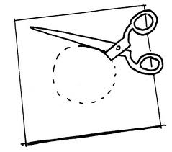
I can cut out ________ circles in 2 minutes.
I should be able to cut out ___________ circles in 4 minutes.
I should be able to cut out ___________ circles in 8 minutes.
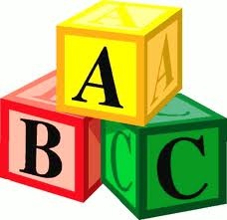
I estimate that I can say the alphabet ______ times in 2 minutes.
I can say the alphabet _______ times in 2 minutes.
I should be able to say the alphabet ____________ times in 4 minutes.
I should be able to say the alphabet ____________ times in 8 minutes.
I estimate it will take me ________ seconds to drink a cup of water.
Drinking a cup of water without spilling it!
To drink a cup of water it takes me __________
To drink 10 cups of water it would take me ___________
I estimate that it will take me _______________ to say the 2x table.
To say the 2 x table it takes me _________________
To say the 2 x table 10 times in a row, it would take me ______________
I estimate that it will take me __________ to put on 3 items of dressing up.
To put on AND take off 3 items of dressing up, it takes me _________________
To put on and take off 3 items of dressing twice, it would take me __________.
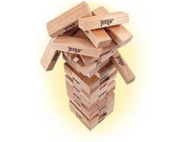
I estimate that in 10 seconds I will be able to balance _______ Jenga bricks.
In 10 seconds I can balance _____________ Jenga bricks.
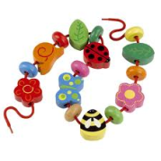
I estimate that in 1 minute I’ll be able to thread ___________ beads.
I can thread ____________ beads on a to a string in 1 minute.
Therefore in 10 minutes I should be able to thread _______ beads on to a string!

Make up your own task!
I estimate that ______________________________________________________
__________________________________________________________________
It actually takes me __________________
What was the difference between your estimation and the actual time it took?

Extra for experts: On a separate piece of paper, work out what the difference is between each estimation and the actual time it took. During which task was your estimation the most accurate? During which task was it the least accurate?

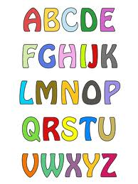

0 x 2 = 0
0 x 2 = 0
1 x 2 = 2
2 x 2 = 4
3 x 2 = 6
4 x 2 = 8
5 x 2 = 10
6 x 2 = 12
7 x 2 = 14
8 x 2 = 16
9 x 2 = 18
10 x 2 = 20
11 x 2 = 22
12 x 2 = 24

1 x 2 = 2
2 x 2 = 4
3 x 2 = 6
4 x 2 = 8
5 x 2 = 10
6 x 2 = 12
7 x 2 = 14
8 x 2 = 16
9 x 2 = 18
10 x 2 = 20
11 x 2 = 22
12 x 2 = 24

