Personal, Social and Emotional Development  -Welcome the new Rising Three children and families  -Peer massage  -Collective Worship  -Social Relationships  -Friendship Tree  -How can we help people across the Sea  -Being part of a team/ groups outside of family and school  -Only one you: I am unique  -Reach for the Stars: your targets for next year  -The Invisible Child: Make everyone feel welcome  -Transition Work for September  -End of Year review and reflection  Religious Education Topics from Come and See-  -The World  -Creation Story  -Life to the full curriculum- RSE | Physical Development  Fine Motor  -Dough Disco  -Squiggle while you wiggle  -Using scissors  -Holding a Pencil correctly  -Wind the bobbin up  -Decorating CD’s  -Weaving  -Musical Instrument work  Gross Motor  -Baby Yoga  -Obstacle Course  -Go Noodle  -Speed and Direction Games  -Balance and Stability Games  -Large Trim Trail  -Sports Day  -Team Games: basketball, football, netball, relay races | Communication and Language Development  -I’m a Little Teapot  -Incy Wincy Spider  -Ten Green bottles  -Hickory Dickory Dock  -Humpty Dumpty  -Guess the Nursery Rhyme from the props  -Mulberry bush, farmers in his den, ring a ring o roses  -Music and songs in other languages  -Music through the ages  -My favourite song  -Nursery Disco  -Guess the Musical Instrument  -Musical Instrument carpet session: slow, fast, low, loud, quiet, high  -Music from different cultures  -Play me a song, play me a rhyme, sing me all about a once upon a time
Cooking and Baking:  Not applicable this term.  Famous Musicians: David Bowie, Ella Fitgerald, Dolly Parton, Little Mix, Elton John, Elvis Presley, Bon Jovi  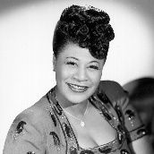 | Musical Maestro  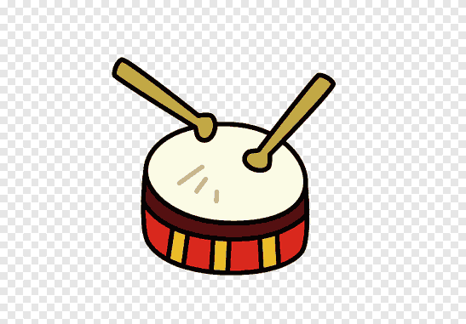 | Key Texts  Ella and Marilyn  Little People, Big Dreams collection  Ernie and the digeridoo
Mathematics  -End of Year Assessments  -Ready to Progress Work |  | Literacy  Phonics Continues  -End of Year Assessments  -Ready to Progress Work
Expressive Arts and Design  -Musical Instruments  -Songs and rhymes  -Traditional Nursery Rhymes  -Movement to Music  -Music from different cultures  -Music from different genres  -Music from the past  -Call and response songs  -Body percussion- clap, tap  -Sound and pitch- high, low, loud, quiet  -Dance to choreographed dances  -Decorate CDs  -Stick and cut records  -Painting musical notes | Events/ Visitors/ Visits  -Open Parents Evening: Discuss Final Report  -Teddy Bears Picnic with our Year 5 Buddies  -Moving up Day: Exploring our new classroom, meeting new friends, introducing ourselves to new teachers  -Trip to the Beach  -Sports Day  -Summer Fair  -The Queens Birthday: The Queens Knickers Day | Understanding the World  - Seasons: Summer- warmth, change in sun, longer days, change in times, growth, plants, flowers, leaves on trees, summer holidays  -Floating and Sinking: Pirate Day session  -Technology: Ipads, mobiles, key boards, tablets, computers, telephones, moving objects, pulleys, record players, cd players, cassette players, TVs, remotes, Gameboys, play stations, xBox.
Vocabulary  -Music: tone, tempo, sound, rhythm, rhyme, cultural, loud, quiet, low, high, soft, hard, slow, fast  -Instruments: drum, tambourine, guitar, shakers, key board, piano, castanets, harp, violin, whistle  -Famous Musicians and their bands | Key Questions  I wonder how music is made? How can I change a sound? The tempo? The rhythm? The tone?  What’s your favourite song? Who is your favourite musician?  Can you play a musical Instrument? Does anybody you know play an instrument?  What sounds can you make with your body and mouth?  How has music changed?  How has technology changed?  Do you have a tv remote? Play station? Tell me how it works? | Characteristics of Effective Learning  Being willing to have a go-  -Initiating activities  -Seeking challenge  -Showing a ‘can do’ attitude  -Taking risks and learning from them  Enjoying Achievement-  -Satisfaction in meeting goals  -Being Proud  -Enjoying meeting challenges for themselves rather than for praise  Choosing ways to do things-  -Planning, making decisions, solving problems, making targets  -Checking how well they are doing  -Changing strategy if needed  -Reviewing their approach

