St Mark’s Nursery activity ideas to try at home
Personal, Social and Emotional Development  Mindfulness  Free Kids’ audio books are still available now. Listen and chill with your little ones and discover a mindfulness exercise in every story.  Listen to Churchy and the Dizzy Buzzy Bee,  https://play.acast.com/s/little-chapters-ofchill/55499836-4c12-424e-83a1-894fc20132eb  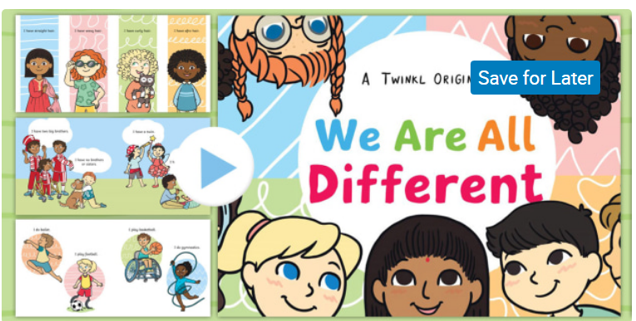  Diversity Powerpoint.  https://www.twinkl.co.uk/resource/tf-or-35-we-are-alldifferent-story-powerpoint  How can I teach my child about diversity? Look throught the powerpoint with your child. Talk about differences and similarities. Being tolerant and getting along with each other. | Communication and Language  Share story books together.  Continue to have fun and share story books together to help your child with early reading skills.  So why not have a go at this challenge!  For the next 30 days (All of June) We’d like you and your child to read or listen to at least one story every day. Keep a record of the stories read.  This can be an audio book or from the internet. However, real books are still best! Handling books is really important for little ones, knowing how to turn the pages, knowing to read from left to right and top to bottom, pointing at words and talking about the pictures are key skills that children learn through books. CBeebies has some great information for parents too  Read the story or listen and watch the powerpoint link below.  https://www.youtube.com/watch?v=pBRT5vsfE3U  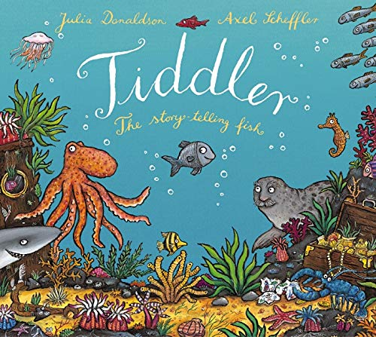  Remember to ask your child about the story. Where did the story take place? Who were the characters, what happened, why? What was your favourite part? Were there any new words the children were unsure of that you could help explain? | Physical Development  Gross motor  Wake up and wiggle, see our Facebook page, Monday, Wednesday and Friday 9:30am  Physical activities for kids – try making up a routine using the cards below. Even better try and have a go at making up your own movements.  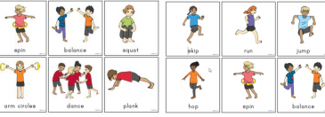  Continue to practise the development of fine motor skills. Threading, cutting, tearing, squeezing, joining with construction, playing with playdough.  It would be great for the children going into Reception to continue to practise writing their first name. Please stick to lower case letters apart from their initials.  Try making your own pencil control patterns similar to the ones you looked at last week.
Maths  Great for number recognition  https://www.bbc.co.uk/cbeebies/watch/playlistnumber-raps  Counting Click on 3-5 years Teddy counting etc  https://www.topmarks.co.uk/maths-games/3-5- - years/counting  Continue to reinforce the language of height at every opportunity. Short, shorter, shortest, tall, taller, tallest  Find toys which are similar eg cars, teddies, balls put them in order.  Continue to reinforce positional language whilst  playing indoors, outdoors or even out for a walk. On top, behind, next to, inside, above, under.  Count everything you can; forwards, backwards, starting from different numbers.  Practise matching numbers to quantities.  https://www.twinkl.co.uk/resource/t-n-1291- counting-matching-puzzle  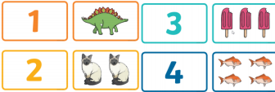  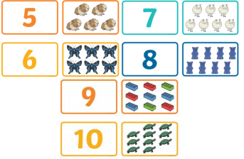 | Creative  Talk about colour mixing, primary and secondary colours. Mix the together to see what colours you can make. Loom at the power point of Kandinsky can you make a circles picture like Kandinsky? | Knowledge and Understanding of the World  Haver a go at this science experiment what happens when you add paint to washing up liquid? Make bubble pictures.  See the resource sheet Making bubbles.

