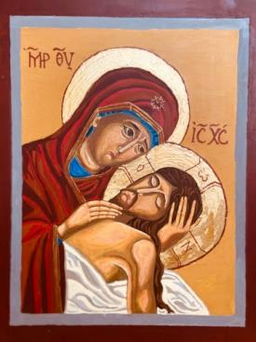

WINDOWS INTO HEAVEN
EXPERIENCING GOD’S LIVING WORD
THROUGH ICONS.

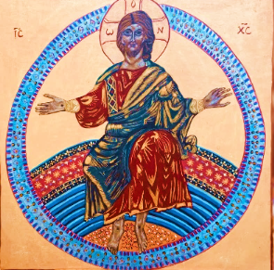

INTRODUCTION
The importance of ‘gazing’:
Gazing at icons is a way to experience God’s word to us. They are part of the Church’s imagery to communicate the Gospel. It is said that an icon is a ‘visual Gospel’. The purpose of both Scripture and Icon is to make present the saving events of Christ’s life. We are transformed by the power of the mystery, so to ‘gaze’ is as important as to ‘listen.’

Communicating God’s Word through icons:
Icons are ‘written’ not ‘painted’ because they communicate the word of God; they are ‘read’ not simply looked at because they communicate God’s transforming love. They invite us to respond and allow God to transform us into his own image. As a result, these sacred icons written in prayer, fasting and silence, carry a divine power within them and mediate it to us.

Why do we pray with icons?
We pray with icons because they lead us into a deeper awareness of the divine presence. When we truly gaze at an icon, it becomes a threshold or window through which we meet the characters in the scene as they come to meet us. It is said that the images make the invisible visible, and the intangible tangible. We gaze upon the scene with ‘receptive vision’ and we allow the encounter to move us deeply and prayerfully.
Praying with an icon is a challenge. As well as a ‘window into heaven’ where we encounter the divine, it serves as a mirror in which we see our own reflection. We are encouraged to recognise in the image, our own desires and yearnings as well as our temptations, sins, and failures. We pray for true transformation by this encounter with the sacred word and image.

Icons depict the teaching of the church:
Icons originated in the Eastern Orthodox Church. They do not appeal, like our Western images to the senses e.g. the Renaissance Madonnas. Rather, they are meant to teach the faith of the Church rather than demonstrate the spirituality of the artist. The artist in fact, does not seek originality but is bound by rules and traditions: colour and gestures are all laid down and followed, though not slavishly. They must be viewed in the context of Scripture so they express and interpret the Word of God to us.

A WAY TO PRAY WITH ICONS

VISIO DIVINA

This is the method of prayer we use with icons. It is the same process as for Lectio Divina, only we don’t read or listen; instead we gaze, not just look at, and allow the sacred image to communicate with us.

There are five stages:
- Read or gaze at the icon and see with the ‘eyes of your heart’ what the mystery portrays (Visio)
- Meditate reflectively on the meaning and message for you, allowing the mystery to mould and transform you. (Meditatio)
- Respond in prayer and dialogue with God e.g. praise, thanksgiving etc. using your own words or a well known prayer. (Oratio)
- Rest quietly with God – a wordless silence in the divine presence, a transforming embrace of union. (Contemplatio)
- Try to live out what you have encountered ie. put God’s Word into action through your committed discipleship. (Operatio)

An easy way to remember this is to think of 5 R’s
- Read (Gaze)- try to understand the mystery being portrayed
- Reflect – in your thoughts and apply to your life
- Respond – in verbal prayer
- Rest – in wordless prayer
- Return to daily life with a practical action.

All the icons in this booklet were ‘written’ by local amateur iconographers who have attended retreat/workshops at the Convent in Seaham, and now Sunderland.

1st Joyful Mystery: The Annunciation

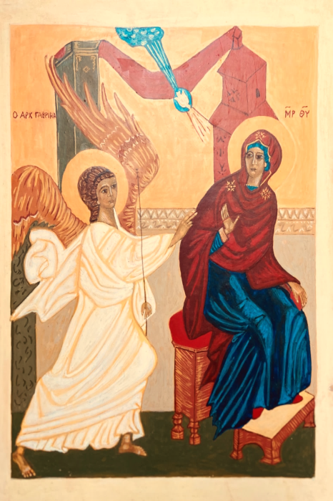
The Angel Gabriel said to Mary, ‘Rejoice so highly favoured. The Lord is with you’. She was deeply disturbed by these words and asked herself what this greeting could mean, but the angel said to her, ‘Mary, do not be afraid; you have won God’s favour. Listen, you are to conceive and bear a son and you must name him Jesus…………..the Holy Spirit will come upon you and the power of the Most High will cover you with its shadow’.
‘I am the handmaid of the Lord,’ said Mary ‘let what you have said, be done to me.’ And the angel left her.
from Luke 1: 26-38
Gaze and read:
Let your eyes rest on the icon with faith and understanding. The artist has captured the alarm and fear of Mary at the Angel’s message, shown by her questioning gaze and raised hand, as well as Gabriel’s re-assuring gesture. Contrast the vivid white of Gabriel’s clothes (glory) with the muted blue (spirituality) and dark red (humanity) of Mary’s dress; the sense of urgency and speed of the angel shown by the wings and feet and the stillness of Mary as she continues to sit, spindle in her hand. Note the image of the Holy Spirit coming from the blue cloud denoting God’s glory. The red drape is a sign that this is an indoor scene.
Imagine the emotions of Mary as heaven touches earth and the Almighty awaits her reply.

Reflect:
- God surprised Mary with the shattering request to be the Mother of his Son. Does God sometimes interrupt your life and turn it upside down?
- Mary’s faith overcame her fear though she had no idea how things would transpire. She had to repeat her ‘Yes’ every day of her life. What am I afraid of in life? Can I say with Mary “Let it be done to me according to your word” and then believe the Angel’s words, “Nothing is impossible to God”?
- By her consent, Mary conceived the Son of God. How can you give a home to God’s word and allow it to transform your life?

Respond: say slowly,
Lord, help me to treasure and ponder on your ways in my life. Give me the grace to answer ‘Yes’ as your will unfolds in my life and to whisper in faith and confidence, ‘Your will be done’. Hail Mary……………….

Rest:
Without the need for words, allow the Holy Spirit to overshadow you as you rest in God’s presence. Draw strength from Mary.

Return:
Can you name your biggest fear? Can you face it today with faith and courage? Think of something practical you can do.

2nd Joyful Mystery: The Visitation

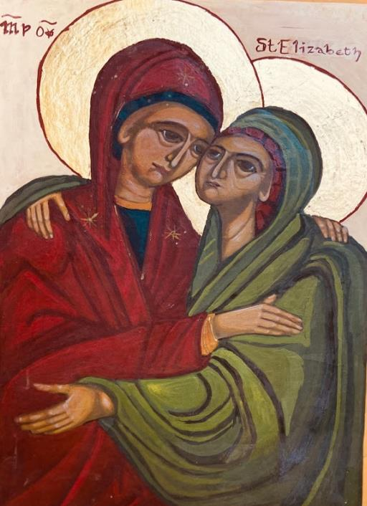
Mary went as quickly as she could to Zechariah’s house and greeted Elizabeth. As soon as she heard Mary’s greeting, the child leapt in her womb and Elizabeth was filled with the Holy Spirit. She gave a loud cry and said, ‘Of all women you are the most blessed, and blessed is the fruit of your womb……. Yes, blessed is she who believed the promise made her by the Lord would be fulfilled.’
And Mary said, ‘My soul proclaims the greatness of the Lord and my spirit exults in God my Saviour.’
Luke 1:39-47

Gaze – Read:
This icon captures the moment of embrace as both the elderly Elizabeth and the young virgin, Mary, rejoice in God’s power made manifest in their lives. Both are pregnant because ‘with God all things are possible’. Elizabeth was to give birth to John the Baptist; the last great figure of Israel and Mary will give birth to Jesus who will bring the new age of salvation to the world. In this scene therefore, the Old and New Covenants meet. Their joyful unity expresses the fact that in Jesus’ birth, the Old Testament would be fulfilled.

Reflect:
- Mary had said ‘Yes’ without realising the full consequences. She had to repeat this ‘Yes’ every day of her life, even under the Cross. Can I identify with her as problems arise in my life?
- God used both women to fulfil his plan of salvation. Does God need you/me to further his work in the world?
- Both Elizabeth and Mary encountered prejudice and suffering in fulfilling God’s will. Does this help us to face difficulties when others may not understand our decisions in life?
- Mary is the ideal Woman of God’s Word. After hearing and consenting to God’s word, she hastened to share it with Elizabeth. Both had surrendered themselves to God’s plan, both were full of gratitude. What qualities of Mary and Elizabeth do you want to imitate in order to become a person of God’s word?

Respond:
Elizabeth’s response forms part of the Hail Mary; Mary’s response is the Magnificat. Pray these prayers and the following:
Mighty and holy one who has looked upon me with favour and grace, open my heart to receive the same blessings of your redeeming love. Strengthen me to believe in your promises.

Rest:
Let yourself rest in God’s presence. Let him fill you and embrace you with a love like that of Mary. Be grateful for her maternal love and understanding.

Return:
How can we actualise God’s word today? Who can we share God’s love with? How can we practically live our faith?

3rd Joyful Mystery: THE NATIVITY

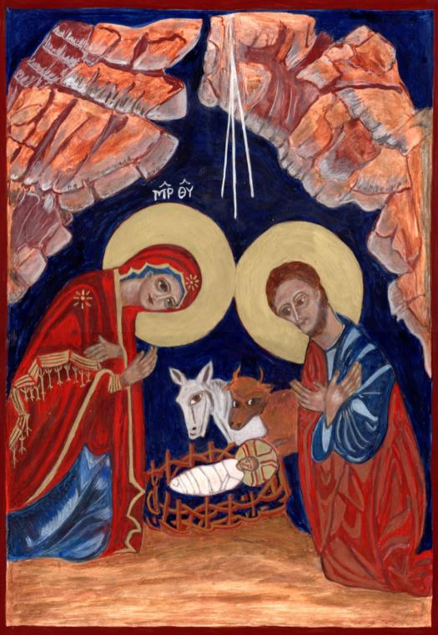

While they were in Bethlehem, the time came for Mary to have her child and she gave birth to a son....... She wrapped him in swaddling clothes and laid him in a manger, because there was no room for them at the inn.
Luke 2:1-7

Gaze and Read:
The sign the angel had given to the shepherds was a child wrapped in swaddling clothes and lying in a manger. This ‘sign’ is the centre of this icon - the child, vulnerable and helpless, loved and adored by Mary and Joseph (though Joseph appear a bit doubtful!) and watched with uneasy curiosity by the ox and ass who have lost their food. But the great truth is that this child born in poverty in a cave with animals, will die on a cross in poverty with criminals; and the child wrapped in swaddling bands and lying in a feeding trough , anticipates the crucified one who will be wrapped in a linen cloth, laid in a rock tomb and ultimately will give his body for our food.

Reflect:
- Mary‘s ‘Yes’ enabled the Incarnation to take place. Is God waiting for my ‘Yes’ to what he is asking of me?
- Because Christ did not choose wealth and power, we can come to him just as we are, poor as we are. As early as the 4th Century, St Athanasius wrote “He became what we are, so that we might become what he is”. The church calls this a ‘marvellous exchange ‘– our humanity for his divinity. What hope does this teaching offer us?
- St Paul says of Jesus: “He was rich, yet for your sakes, became poor, so that by his poverty, you might become rich” (2Cor 8:9) How does the poverty, weakness and vulnerability of Jesus, provide you with abundance and strength?

Respond:
Lord Jesus, help me to understand that you, the Word of God, ‘were made flesh and dwelt amongst us. It was love that brought you to earth. May the morning star rise in my heart and may you become flesh in my heart and in my life so that I can help to bring you to birth in all that I meet.

Rest:
Repeat slowly and continually, ‘Christ is born!’ ‘Glorify him!’ Use this mantra of the Eastern Church, to still your mind and heart.

Return: Choose a practical way to bring Christ to others – an act of kindness, a visit, a phone call etc.

4th Joyful Mystery: The Presentation in the Temple

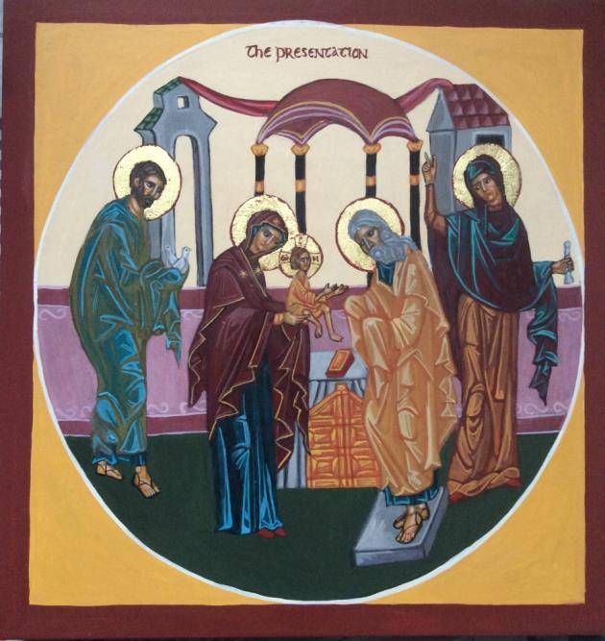

When the time for their purification according to the Law of Moses, they brought Jesus up to Jerusalem to present him to the Lord... It had been revealed to Simeon that he would not see death until he had seen the Lord’s Messiah....and Anna, coming up at that time gave praise to God and spoke of the child to all who looked for the deliverance of Jerusalem”
Luke 2:22-38
Gaze and read:
Mary has just given her child to Simeon who bends low in reverence, recognising him as the long-awaited Messiah. In the person of Simeon, the world’s old age welcomes into its arms, the eternal youth of God. Simeon can now die in peace for “my eyes have seen your salvation, a light for the revelation to the Gentiles and for glory to your people Israel”. But at this moment of joy, he foretold that a sword would pierce Mary’s heart as her son would be opposed. Joseph carries the offering of the poor- two turtle doves for sacrifice in the Temple. Beside Simeon is the faithful Anna, who rejoiced that the old prophecies were being fulfilled. Gaze into the faces of these holy and faithful ones who are being rewarded for their fidelity and belief in God’s promises.

Reflect:
- What do Simeon and Anna teach us about the need for watchful waiting on God’s will to be accomplished? Do we find patient expectation a difficult thing?
- What are some of the ways in which the heart of Mary will be pierced throughout the life of Jesus? What does Mary teach us about the inevitability and value of suffering? How can she teach us to suffer in ways that expand our hearts and that help others to see meaning and hope in the midst of pain?
- Each of the figures in the icon is exemplary for his/her trust in God. How could your life be different if you trusted God completely?

Respond:
Lord God who brought salvation to the world, through your Son Jesus, let me receive him into my arms and let his love penetrate my heart. Give me the gift of faith, so that I may trust in you completely, the gift of hope that I may see past life’s sufferings, and the gift of love that I may welcome your presence in my life. Continue in your own words.

Rest:
Let the light of Christ shine into your heart. When words become inadequate, spend time in contemplating the presence of Christ within you.

Return:
Be alert to recognise God touching your life today.
5th Joyful Mystery: Jesus is found in the Temple

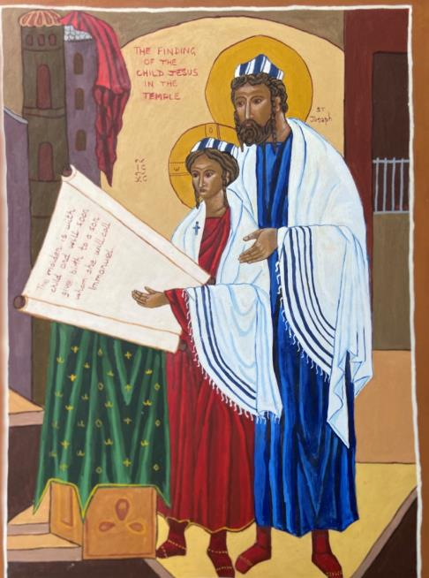

When he was twelve years old, his parents took Jesus up to Jerusalem for the Passover. When the festival was over, the boy Jesus stayed behind and his parents assuming that he was in the group of travellers, did not know......They returned to Jerusalem to search for him and after three days, found him in the Temple among the teachers and doctors of the Law. His mother said to him, “Child, why have you treated us like this” ......
He said to them,” Did you not know that I must be in my Father’s house?”
Luke 2:41-52

Gaze and read:
This is an unusual portrayal of the Finding in the Temple. Joseph has taken centre stage and we see him here guiding and teaching Jesus in the reading of the Law. At the age of twelve, Jesus was considered ready to accept the responsibilities of the Torah. Both are dressed as orthodox Jews with prayer shawls, yarmulke (skull cap) and ringlets. Joseph is in a protective stance and both are studying the prophecy of Isaiah referring to the birth of Emmanuel. Both have a look of realisation that this refers to the boy Jesus. His holding the scroll, indicates that his teaching is rooted in the Law and the prophets of Israel. For all faithful Jews, the Temple was the focus of God’s presence in the world and the centre of their worship.

Reflect:
- Jesus was lost for three days and then found. We can only imagine the trauma of the parents. What can we learn from the Holy Family about the joys, challenges, struggles and blessings of family life?
- Mary is not portrayed in this icon but she ‘treasured all these things in her heart’ and trusted. Is there a lesson here for me, when I don’t understand why things happen as they do?
- At some point, parents realise that their children do not belong to them. Here, Joseph and Mary realise their son is called to a life devoted to God’s plan. What does this teach us about the raising of children?

Respond:
Respond to this narrative in your own words by imitating the trusting faith and humble acceptance of Mary and Joseph. Pray for all families especially ones that are in crisis and pray for all children who have left home in bitterness and anger.

Rest:
Remain in restful quiet, saying over and over,
Trust, Surrender, Believe, Receive.

Return:
Reach out to an estranged family member or pray for reconciliation within your family.

1st Mystery of Light: Baptism of Jesus
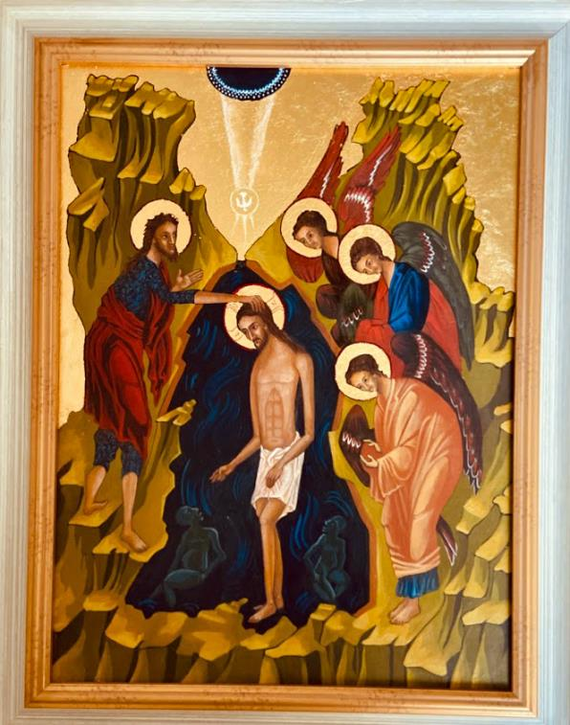

s soon as Jesus was baptised, he came up from the water, and suddenly the heavens opened and he saw the Spirit of God descending like a dove and coming down on him. And a voice spoke from heaven, ‘This is my Son the Beloved; my favour rests on him.’
Matthew 3:13-17

Gaze and read:
The focus in this icon is clearly on Christ as he stands humbly in the Jordan, symbolising the messiness of our own lives. He came to share our sinfulness though he was without sin and is blessing the two other figures in the water, representing our unredeemed selves. His thoughtful expression suggests that he knows exactly what he is doing. The Baptist on the left, also captures the significance of the moment, as do the angels, hands covered in reverence. Jesus’ Baptism reveals the Holy Trinity to the world: the blue semi-circle depicts the glory of God from which comes the voice of the Father, and from this glory a shaft of light descends on Jesus representing the Holy Spirit, and animating Jesus for his ministry to the world.

Reflect:
- The exchange between Father, Son and Spirit demonstrates the relationship to which we are all called. Through Baptism, we become the beloved sons and daughters of God. How has your Baptism affected your relationship with God?
- Jesus was commissioned at his Baptism to begin his work to establish God’s kingdom on earth. By Baptism, we too were commissioned to do the same. Do I know what my particular mission is?
- By going down into the water, Jesus took upon himself the guilt of our sins but was affirmed by his Father and clothed with strength by the Holy Spirit. Can we see this as the pattern of our lives – going down and coming up, sinning and being forgiven, dying and rising?

Respond:
Father, stir up in me the grace of my own Baptism. Send your own Spirit to enliven me, guide me and make me generous in your service. Continue in your own words ...........

Rest:
A few moments of quiet realisation that you are God’s beloved child and nothing, even sin, can alter this. Rest in thanksgiving and trust.
Return:
Baptism calls us to active discipleship. Choose one thing that will outwardly express this commitment to Christ and further God’s kingdom.

2nd Mystery of Light: The Marriage Feast of Cana
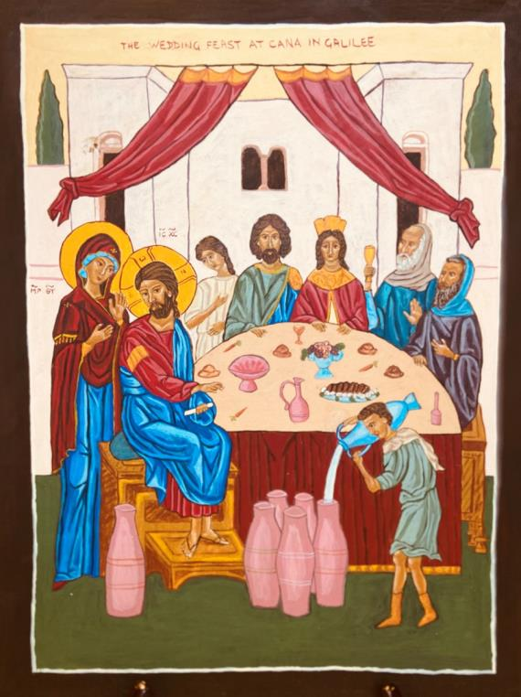
When they ran out of wine, the mother of Jesus said, ‘They have no wine’. Jesus replied, ‘Woman, my hour has not yet come’. His mother said to the servants,’ Do whatever he tells you’.
Jesus said,’ Fill the jars with water’ and they filled them to the brim.... The steward tasted the water and it had turned into wine.
John 2:1-11

Gaze and read:
This is the first ‘sign’ of John’s Gospel pointing beyond the event to the truth about who Jesus is – the Messiah who will fulfil the Old Testament longings (the water) with the rich new wine of the banquet of God’s love made present in Christ Jesus. This icon emphasises the role of Mary as the one who precipitates his ‘hour’, the beginning of his public ministry, and teaches us obedience to his word’, “Do whatever he tells you”. John’s Gospel tells us, that this miracle revealed his glory and that his disciples now believed in him. They are hidden from sight in this icon because we, the viewers, are the disciples. We are challenged to see the first of his ‘signs’ and believe in hm. For those who believe in him, life will never again be predictable, bland and colourless like water. Rather, in him, life is rich, vibrant, and invigorating like wine.

Reflect:
- Mary’s role in this incident is crucial: she notices the shortage of wine; she initiates the action. What does this say to us of trust, expectancy and obedience?
- What is my relationship with Mary? She has been called the ‘model disciple’. What qualities of discipleship can I learn from her?
- In Judaism, wine is an expression of joyful celebration, of feasting when the Messiah comes. Jesus is here now with us. Is my relationship with him, one of gratitude and joy or has my relationship with him lost its sparkle?

Response:
Lord of my present and future, thank you for manifesting the power of your divine generosity at a family gathering. Transform my life from ordinary, mundane existence to abundant living. Help me to do whatever you tell me and give me a lively hope in the glorious wedding feast you have promised.

Rest:
Silently rejoice in God’s goodness, his gifts, his abundant love. Believe in his promises.

Return:
What, in my life, can I transform from ‘water’ to ‘wine’ by a change of attitude and mind-set?
3rd Mystery of Light: Jesus proclaims the Kingdom of God

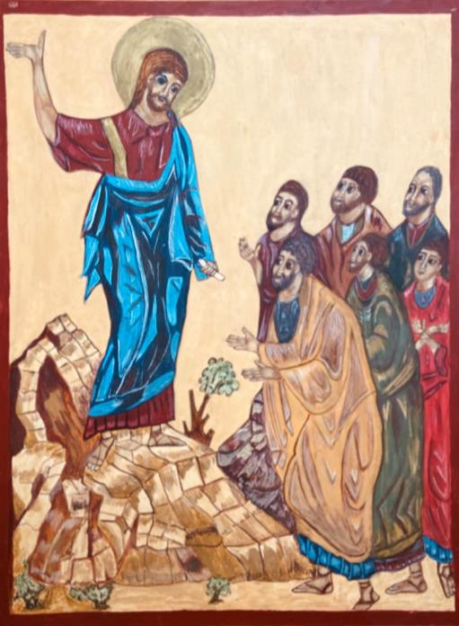

Jesus came to Galilee, proclaiming the Good News of God and saying,
“The time is fulfilled, and the kingdom of God is near; repent, and believe in the Good News. As he passed along the Sea of Galilee, he saw Simon and his brother Andrew casting a net into the lake and he said to them, ’Follow me and I will make you fishers of people’ And they left their nets and followed him.
Mark 1:14-18

Gaze and read:
Jesus is saying, ‘The time is right now, to bring my Father’s plan of salvation to completion; the kingdom, the reign of God, is near. He is ushering in a world of love, justice, peace, compassion and joy. This is the Good News for those who choose to accept it and live by it. The icon shows the uncomprehending faces of the first Apostles as Jesus unfolds the requirements of the kingdom: to repent – to adopt a complete change in mind-set and believe in the Good News by leaving their old lives and yielding to everything that God will do through Jesus. They are being called to discipleship, to follow a different way – and this will bring happiness and fruitfulness as they ‘catch people’. Jesus holds the Charter of the Kingdom, the Sermon on the Mount, which contains his most radical and precious teaching.
Reflect:
- Jesus came to bring the kingdom of God into a world of sin and selfishness, not unlike ours. Can we see any signs of the Kingdom of God around us?
- Simon, Andrew, James and John responded immediately to Jesus’ “Follow me”. What would be my response? What attachments, fears etc must I leave behind, to place the kingdom first in my life?
- Read the Sermon on the Mount in Matthew Ch 5-7. The teaching can be overwhelming but this is what is required, if I am to be a follower of Christ. Am I up to the challenge and if not, why not? God would not ask the impossible from us.

Respond:
Say the Lord’s Prayer slowly and fervently. Ask for the graces necessary to “know Christ more nearly, to love him more dearly, and to follow him more clearly, day by day.” (St Richard of Chichester)

Rest:
Fix your eyes on the serene face of Jesus as the Apostles do in this icon, and repeat: Trust, surrender, believe, receive until you are at peace.

Return:
Choose one practical way you want to change, so as to become more a kingdom-person.
4th Mystery of Light: The Transfiguration
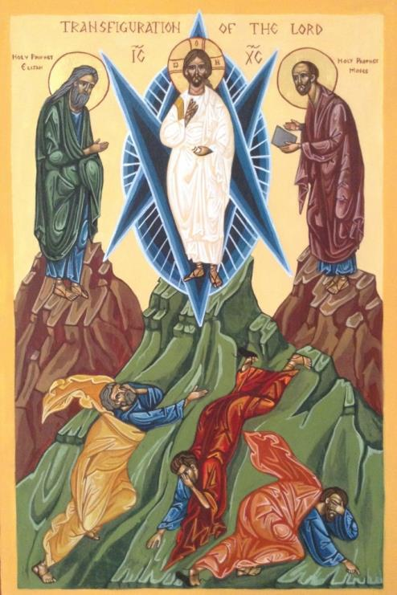
Jesus took Peter, James and John and led them up a high mountain. And he was transfigured before them, his clothes became dazzling white...
And there appeared to them Elijah and Moses who were talking with Jesus. Then Peter said to Jesus, ‘Rabbi, it is good for us to be here; let us make three dwellings, one for you, one for Moses and one for Elijah. He did not know what to say for they were terrified. Then a cloud overshadowed them and a voice from heaven said ’This is my Son the beloved, listen to him’
Mark 9:2-10

Gaze and read:
The glorified Christ is the centre and focus of this image, his hand held in blessing, eyes directed at us. His clothes are dazzling white and he is surrounded by a mandorla, symbolising the glory of God and the coming together of heaven and earth. Next to Jesus are Elijah and Moses, showing that Jesus is the fulfilment of both the Law and the Prophets. These are contrasted with the frightened and confused figures of the Apostles: Peter, speaking inappropriately of dwellings (‘Let’s do something’), John has fallen backwards at the vision and James is shielding himself from the brightness. The Transfiguration points towards the final glory of Christ but only after his suffering and death. The Apostles missed the point. They neither saw nor listened.

Reflect:
- Often in our lives, we do not see clearly what God is doing. Are we able to see the glory of God’s presence shining in the lives of those around us? What would give us clearer vision?
- God tells the disciples to listen to Jesus as he teaches them the way of discipleship which entails suffering. How is my listening? Where am I being challenged?
- Jesus was transfigured so that his divinity shone through his humanity. This is the aim of all our prayer – to become more like Christ, divinised. Do I really believe this and let God do his work in me?

Respond:
Lord Jesus, you were transfigured on the mountain to reveal your glory and strengthen the faith of the Apostles. Show yourself to me; cleanse my eyes to help me to see your glory under so many disguises. Transfigure my sufferings, inadequacies, and failures, so that they may lead me closer to you. Enkindle the spark of divinity in me and in those around me.

Rest:
“I live, now not I, but Christ lives in me” Hold on to this wonderful truth, expressed by St Paul and rest confidently in God’s presence.

Return:
Resolve to see Christ in those around you today.

5th Mystery of Light: Jesus leaves us the Eucharist
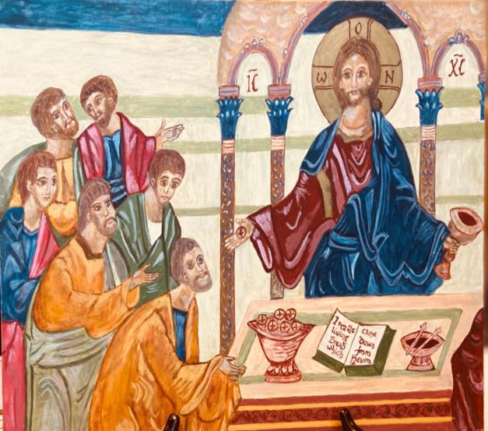

While they were eating, Jesus took bread and after blessing it, broke it, gave it to his disciples saying, ‘Take, eat, this is my body.’ Then he took the cup and after giving thanks he gave it to them saying, ‘Drink from this all of you, for this is my blood of the covenant, which is poured out for many for the forgiveness of sins’ ‘Do this in memory of me.’
Matthew 26:19-30

Gaze and read:
This icon portrays the last Supper when, consecrated and sanctified, the bread and wine become the Body and Blood of Christ. He feeds us with his own being so that we might become participants in the divine nature. We come to this great sacrament to experience over and over the mystery of our redemption – Christ’s body is sacrificed, his blood poured out for us, thus uniting us intimately to his death and resurrection. The Apostles are uncomprehending; how could they possibly understand? In the Eucharist, we are one with his crucified, risen and glorified body. It constantly renews and increases our life in Christ. The Eucharist is the “Source and Summit” of the Church’s life. Without the Eucharist, there is no Church.

Reflect:
- In Jesus’ gift of the Eucharist, he offers his Body for our food and Blood for our drink. When we say ’Amen’ we agree to become ‘Eucharist ‘ for others. How can I live and be Eucharist?
- To give oneself so utterly is the extreme of love. Have I become too familiar with Jesus’ total self-giving as gift?
- We cannot live and grow without food; we cannot live spiritually without the food of the Eucharist. Do I appreciate the constant nourishment and abiding presence of Jesus in the Eucharist?

Respond:
Say the Anima Christi (Cardinal Newman’s translation) with love and gratitude:
Soul of Christ be my sanctification; body of Christ be my salvation,
Blood of Christ, fill all my veins; water from Christ’s side wash out my stains,
Passion of Christ, my comfort be; O good Jesus listen to me.
In thy wounds I fain would hide; never to be parted from thy side,
Guard me should the foe assail me; call me when my life shall fail me,
Bid me come to thee above; with thy saints to sing thy love,
World without end. Amen.

Rest:
Concentrate on your total oneness with Jesus for as long as you can.

Return:
Determine to increase your reverence and love for the Eucharistic presence of Jesus. Spend some time before the Blessed Sacrament.
1st Sorrowful Mystery: The Agony in the Garden

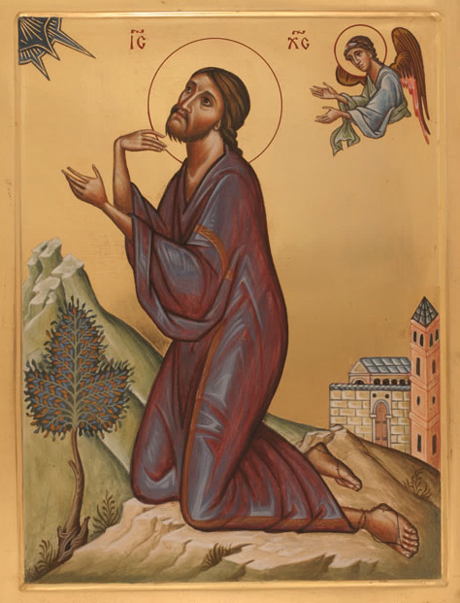

Then Jesus went to a place called Gethsemane----he began to be grieved and agitated .... he threw himself on the ground and prayed,” My Father, if it is possible, let this cup pass away from me, yet not what I want but what you want.’ ......
He went away for a second time and prayed,” My Father, if this cannot pass unless I drink it, your will be done”. ...Then he said to his disciples, ‘See the hour is at hand and the Son of Man is betrayed into the hands of sinners.’
Matthew 26:36-46
Gaze and read:
Here, we see a very human Jesus. Death is staring him in the face and he is sorrowful and afraid. He is staring with apprehension yet love, at his Father’s face symbolised by the blue ‘mandorla’ in the corner, and pleading for a way out. The gesture of his right hand suggests,’ Why are you asking this of me? This is the moment of decision for Jesus. He is afraid but completely willing to embrace his suffering for the sake of his love for humanity and to carry out his Father’s plan for the world’s salvation. This is a struggle he has to undergo alone (his Apostles were asleep) but he is strengthened in his resolve by an angel.

Reflect:
- Jesus did not flee from his suffering but remained in prayer. He accepted his death as the highest form of love. In what way does the agony of Jesus guide you in the face of suffering and death?
- Although Jesus was divine, he was also fully human and here we see a conflict of wills – human and divine. In what way is your faith enriched by seeing the ways that Jesus experienced struggles similar to your own?
- Imagine you are one of the sleeping apostles. How would you feel when you realised what Jesus was enduring and then saw him arrested and taken away?

Respond:
Lord Jesus, when I feel crushed under the weight of a trial , grant that I may have the grace to unite my prayer with yours and have the strength to say with you ‘Father let your will be done, not mine’. Help me to entrust my life into your hands. Continue to pray for strength and wisdom and especially for acceptance of God’s will for you, even when you don’t understand.

Rest:
Place yourself beside Jesus as he prays, seek to join your heart to his and remain in silent compassion and contemplation, accepting the transforming grace God desires to give to you.

Return:
Leave your tensions and problems with God and work for a deeper trust that he knows what is best for you.

2ND Sorrowful Mystery: The Scourging at the Pillar
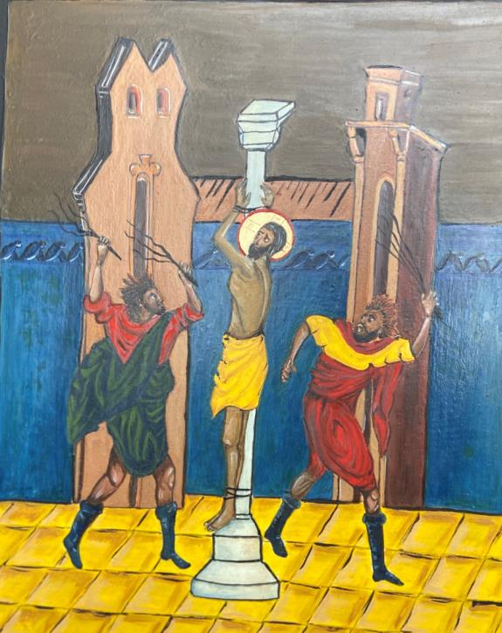

Pilate released Barabbas and had Jesus scourged
and handed him over to be crucified.
Matthew 27:26

Gaze and read:
This icon portrays the brutal lashings that Jesus endured at the hands of the Roman soldiers. The prophet Isaiah had described the sufferings of the suffering servant and the meaning of that suffering for God’s people. The servant was “despised and rejected, smitten, stricken and afflicted. (Isaiah 53: 3-4). The servant proclaims, “I gave my back to those who struck me” yet he was innocent and his sufferings were for our sake. “He was wounded for our transgressions and crushed for our iniquities and by his stripes, we are made whole”. (Isaiah 53:5). The icon expresses not only the physical torment of Jesus, but more importantly, the meaning of that suffering. Jesus was afflicted by the whips of the Roman soldiers but his wounds are for our healing.

Reflect:
- Christ is a wonderful physician: he heals by taking the sicknesses of people upon himself. Through his suffering and death, he has redeemed the world. Present the ills of the world to him now for his compassion and healing?
- Why is our world saturated with violence, hostility, rage? How does this scene express the aggression of those who inflict suffering on the innocent? Do I remain silent in the face of injustice and cruelty?
- “By his stripes, you are healed”. In what personal ways are you grateful that Christ is a wounded healer? What do you want to be healed from?

Respond:
Suffering Lord, scourged for no reason, and handed over to be crucified, have mercy on me in your steadfast love, forgive my sins and heal me from all that prevents me from being whole. Strengthen me by the great love of your sacred passion. Continue in your own words.

Rest:
When words seem inadequate, remain in prolonged silence before Jesus’ suffering with a thankful heart and a contrite spirit.

Return:
As you contemplate the darkness around and within you, resolve to bring Christ’s light into one small corner of society, by reaching out to some- one in need.
3rd Sorrowful Mystery: The Crowning with Thorns
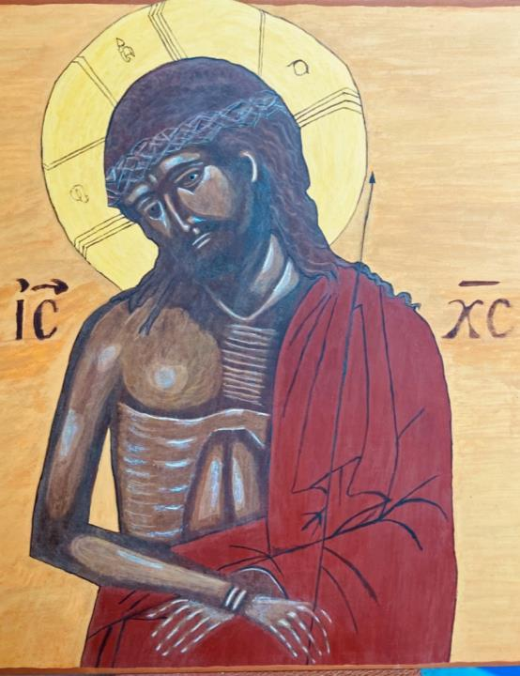
Then they stripped him and put a scarlet robe on him, and after twisting some thorns into a crown, they put it on his head. They put a reed in his right hand and knelt before him and mocked him, saying, ‘Hail, King of the Jews!’ They spat on him and took the reed and struck him on the head. After mocking him, they led him away to be crucified.
Matthew 27:22-31.
Jesus came out, wearing the crown of thorns and the purple robe. Pilate said to them, ‘Here is the man!’
John 19:5
Gaze and read:
Humiliation, mockery, sarcasm are the keynotes of this scene. Ironically, when the soldiers mocked Jesus as King, they spoke a profound truth but his kingship was hidden in lowliness and suffering. ‘Here is the man - your king ‘, broken in body, shaking with pain, laughed at and derided, bloody and beaten stripped of dignity and identity and yet never more a king. This is the history of man’s inhumanity to man. This is what hatred and violence does to human beings – from the gas chambers of Auschwitz to religious persecution and racial prejudice today. Looking at Jesus forces us to see what we do in the name of war, ethnic cleansing, terrorism, religious extremism, to the least of our brothers and sisters and to the innocent.

Reflect:
- Hail Redeemer, King divine! How is the reign of Christ different from the kingdoms of the world with their power and brutality?
- To be a member of the Kingdom of God is to have the mind and heart of Jesus. Do I resemble him in any respect?
- When I pray ‘Your kingdom come’, what am I really praying for?
- From the midst of our struggles and indecisions, can we recognise that God is still king of our lives and has our best interests at heart?

Respond:
King of heaven and earth, of life and death, of sorrow and joy, of today and tomorrow, reign over my life. Take all that worries me, my burdens and wounds and transform them into a glorious crown so that I may share some day in your glory.
The King of love my Shepherd is, whose goodness faileth never;
I nothing lack if I am his and he is mine forever.

Rest:
Look on the face of Jesus and let his gaze penetrate your heart. Remain in this face to face encounter as long as you can, with sorrow and compassion and without words.

Return:
Mercy and forgiveness are the fruit of Jesus’ suffering. How can I exercise these virtues with those around me?

4th Sorrowful Mystery: Jesus carries his cross to Calvary
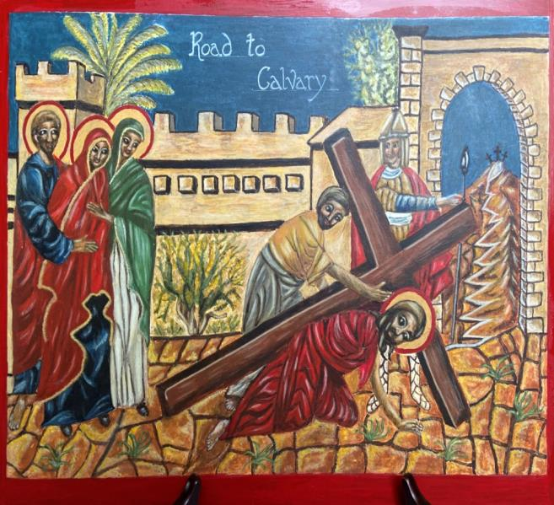

And they led him away to be crucified. As they led him away, they seized a man, Simon of Cyrene and made him carry the cross behind Jesus.
A great number of people followed him, among them women who were beating their breasts and wailing.... Two others who were criminals were led away to be crucified with him.
Luke 23:26-34

Gaze and read:
Jesus goes to his death, carrying his own cross, but already physically weak from his scourging. The soldiers feared he would die before his crucifixion so they coerced a random stranger, Simon of Cyrene, to help carry the cross. What seemed like an indignity, to carry the cross of a condemned criminal, soon became his moment of glory. To take up the cross and follow him, was the way Jesus had defined discipleship. His chosen disciples had fled but this stranger came to represent true discipleship for all who would hear the Gospel of Jesus’ passion. Look into this scene – the Roman soldier forcing the pace, and his beloved Mother Mary, the devoted Mary Magdalen, and the ever faithful John sharing his sufferings and silently supporting him.

Reflect:
- Jesus’ way of the cross is our way too. He takes upon himself the burden of the world’s suffering. How can we show solidarity with suffering people everywhere?
- Jesus gratefully accepted Simon’s help. When have you found it difficult to carry your cross? Who helped to make your burden easier? Turn to Mary, Mother of Sorrow for help.
- Jesus submitted to everything we fear: humiliation, rejection, pain, failure, death. He did this out of love. Am I indifferent to the sheer cost of my redemption?

Respond:
Suffering Lord, teach me to take up my cross and follow you each day. You are the Lamb of God who takes away the sin of the world. Give me the grace to hand over my sins to you and unite my crosses, large and small to yours for the salvation of the world.

Rest:
Look into the face and eyes of Jesus as he carries his cross along the way. Identify with Mary, John and Mary Magdalen in their silent support. Let Jesus’ mercy transform your heart, and let him give you the gift of compassion.

Return:
Resolve to walk in solidarity with suffering people everywhere. Do something practical to share in another’s sufferings today.
5th Sorrowful Mystery: Jesus dies on the Cross
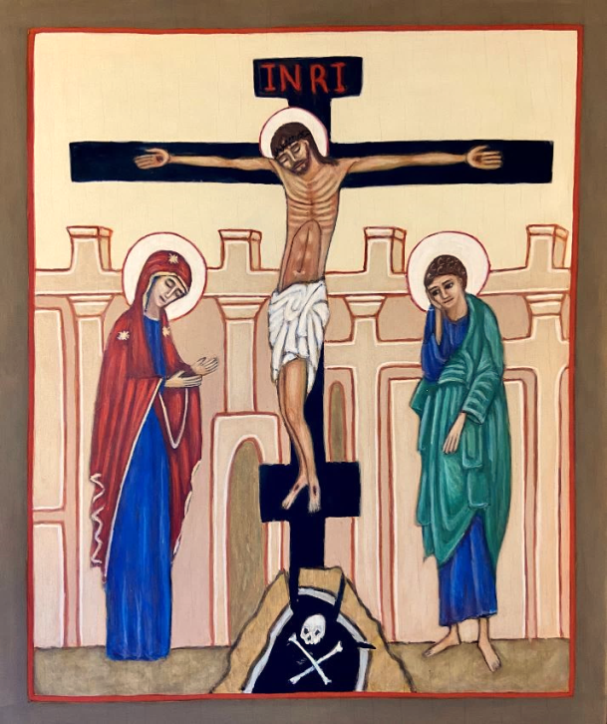
The inscription on the Cross read ‘Jesus of Nazareth, King of the Jews’...... ...Meanwhile, standing near the cross of Jesus were his mother and the disciple whom Jesus loved...When he saw his mother, he said ’Woman behold your son’. Then he said to the disciple ‘Here is your mother and from that hour the disciple took her into his own home...When Jesus had received the wine, he said, ‘It is finished’. Then he bowed his head and gave up his spirit”
John19: 19-30

Gaze and read:
The icon does not emphasize the agony of the cross but its nobility and significance. This is life lived with love to the end. The cross is our most powerful reminder that God is with us even in pain, tragedy and apparent hopeless situations. In looking at Christ crucified, we see the saving love of God expressed conclusively. On the cross, Jesus had to let go of his possessions - even his clothing; his family – even his mother and finally life itself. The cross in the Orthodox church, has three vertical bars; the top bar for the sign, represents kingship; along the middle bar, stretch the arms of Christ which embrace the world, and the bottom bar is the footrest. Beneath the cross, the hill of Golgotha, split by an earthquake, reveals the skull of Adam. Christ is the new Adam redeeming the world from the consequences of sin.

Reflect:
- Is it helpful for us to see the cross not as an instrument of humiliation but as a sign of victory? This is the cross as seen by God the Father; Christ has conquered evil and death itself. Love is stronger than death. Do I really believe this?
- When Jesus breathed out his spirit, the Church was born. Blood and water from Christ’s side represent Baptism and the Eucharist. At every Mass, the grace of Calvary is renewed. How grateful am I?
- At the foot of the Cross, Mary became the Mother of the Church, when Jesus gave her tenderly to John, representing all the disciples. How does Mary’s maternal care help us to follow in the way of her Son?

Respond:
We adore you O Christ and we praise you because by your holy cross, you have redeemed the world and brought your church to life. Continue to breathe your spirit into us that we may be your faithful disciples. In all our suffering and even in death itself, let us find you. Continue in your own words.

Rest:
Let your eyes rest on the cross of Jesus. Let the eyes of your heart, enter into his loving sacrifice. Feel bathed and renewed in his precious blood.

Return:
Jesus’ death was life-giving to us. Is there any way that you can bring fuller life to another?
1st Glorious Mystery: The Resurrection
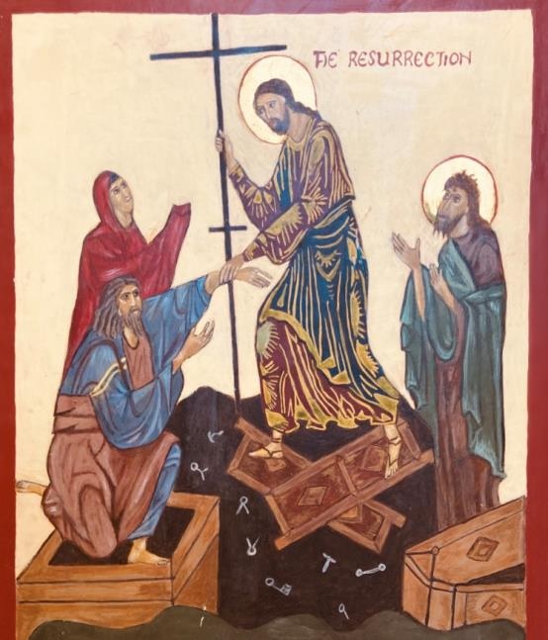

Jesus cried with a loud voice and breathed his last. At that moment, the veil of the Temple was torn in two, from top to bottom. The earth shook and the rocks were split. The tombs also were opened and many bodies of the just who had fallen asleep were raised.
Matthew 27:50-53

Gaze and read:
The centre of Christian faith is Jesus Christ risen from the dead. This icon, sometimes called the Harrowing of Hell, shows Christ’s complete victory over the power of death. He descends into the darkness of Sheol, the place reserved for those who died before his victory. They are not forgotten but are raised up to life with him. Christ is shown in his divine glory, breaking the gates of the underworld, scattering bolts, locks and hinges, and lifting up the ancestors of humanity, Adam and Eve. Pulling them by the wrist denotes their dependence on him; they humbly surrender to his divine power. To the right, is John the Baptist, awaiting the fullness of salvation.

Reflect:
- The entire life of Jesus was a descent into the depths of humanity. What is the lowest point in my life to which Jesus has descended? How has he lifted me up to share new life in him?
- In what way does this icon of Christ’s victory seem richer than other expressions of Christ emerging from the empty tomb? As you gaze on it, what hope does it offer to you?
- No one is beyond redemption; Christ descended into the underworld to rescue so many Old Testament figures. He wants everyone to share with him the fullness of his divine life. Do I really believe this and how well do I appreciate it?

Respond:
Risen Lord, descend into the darkness of my life and destroy the fears and powers of death within me. Lift me up to share in your victory and give me a joyful hope in the world to come. Continue praying in your own words.

Rest:
Place yourself in the darkness of life – suffering, anxiety, fear, doubt.
Let the light of Christ shine on you; let him lead you into the fullness of his presence. Know that the time of waiting and uncertainty is over, conquered by Christ’s love and transforming grace. Surrender yourself to this love.

Return:
Reach out today, to lift the spirits of someone who is in darkness.
Share in a practical way, the power and energy of the risen Christ within you.

2nd Glorious Mystery: The Ascension
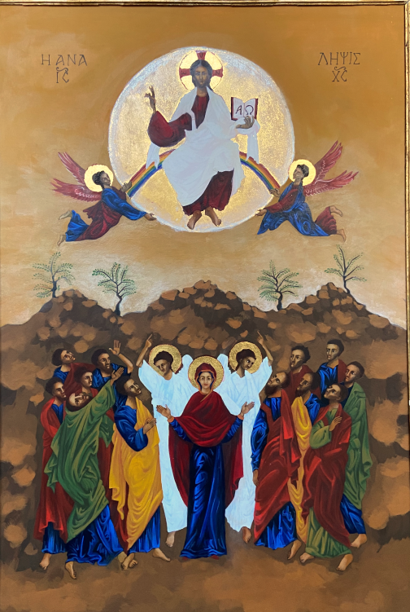I
And Jesus said, ’You will receive power to be my witnesses to the ends of the earth.’ And he was lifted up and a cloud took him out of their sight....
And two men in white robes said,’ Men of Galilee, why are you looking upwards. This Jesus who has been taken up into heaven will come as you saw him go into heaven’
Acts 1:8-11

Gaze and read:
Here, we see the glorified Christ in majesty and triumph. The disciples, in confusion do not yet realise that the one who has taught, healed and loved them will no longer be seen by them but will be present in a way they do not yet understand. He has given them a mission: to be his witnesses to the ends of the earth. They are not to stand looking upwards because they have a task ahead of them – the evangelisation of the world. But they must wait for the Spirit to empower them. In the centre stands Mary, the mother of the disciples and the mother of the church. She is not staring upwards but lovingly towards us. She understands better than ever the mysteries of her Son’s birth, death and resurrection, already hoping for his return. This hope gives her true wisdom and peace, shared by Christ and the angels in white.

Reflect:
- In what way is the church continuing the mandate of Jesus to be his witnesses throughout the world. Do we take seriously our role to be “missionary disciples”?
- Christ intercedes with his father on our behalf. Could the Father refuse him anything? What important things do I need to pray for?
- Contrast the disciples with Mary. She is not only the mother of the saviour that brought divinity to humanity but now she is mother of the church bringing humanity to divinity. How does Mary fulfil that role in your own life?

Respond:
Risen and glorious Lord, who has ascended to appear in the presence of God on our behalf, give me the courage to be a witness to the Good News. Help me to do your will on earth as it is done in heaven until you come in glory. Continue to pray for the gifts and empowerment of the Spirit in your life and in the church.

Rest
Look into the face of Mary in the icon and let her serene acceptance lead you into wordless prayer of trust and surrender to God’s will.

Return: In what direction is the Lord sending you today, to share his love and peace with others?

3rd Glorious Mystery:
The Descent of the Holy Spirit on the Church

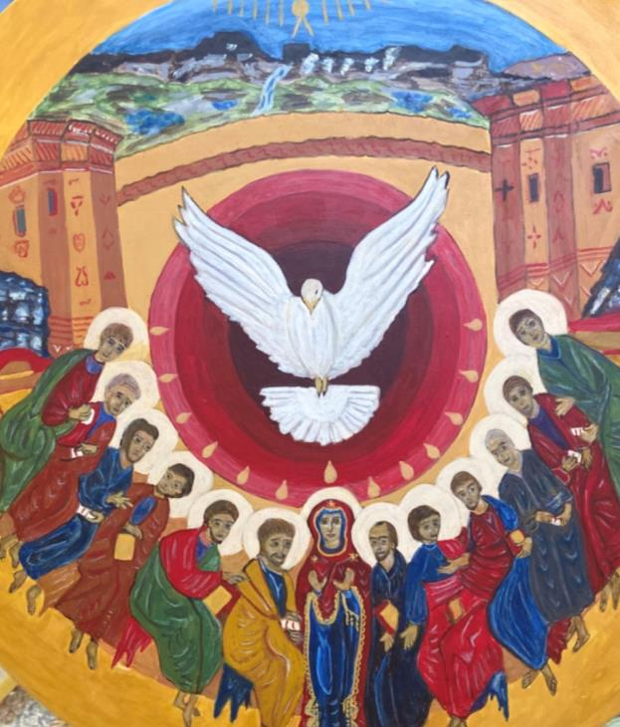
When the day of Pentecost came around, they were all together in one place. And suddenly from heaven, there came a sound like the rush of a violent wind, and it filled the house where they were sitting. Divided tongues of fire appeared among them, and a tongue rested on each of them. All of them were filled with the Holy Spirit and began to speak in other languages as the Spirit gave them the ability.
Acts 2: 1-5

Gaze and read:
This icon shows the moment when the Church was born. The fire of the Holy Spirit stirred into flame the grace of Christ’s death and resurrection and breathed divine power into the new-born church. At the top, is the familiar blue semi-circle, the mandorla, symbolising the presence and glory of God. The single ray of light for each of the twelve disciples burst into tongues of fire resting on each, empowering them with the Spirit’s supernatural gifts. Mary, as Mother of the Church, is in the centre. The Holy Spirit, in the form of a dove, fills the church and anoints its ministers.

Reflect:
- At Pentecost, the apostles are transformed and united, ready to carry the message of the Gospel to the world. Do we believe today in the Spirit’s transforming power –in the church; in our own lives?
- The power of the Spirit has worked wonders throughout history. What wonders is the Holy Spirit working in and through believers today?
- Do I recognise the church as a Spirit-filled, dynamic body of Christ and myself as an essential, active member?

Respond:
Come Holy Spirit, everywhere present and filling all things, sanctify my heart for the glory of God’s kingdom. Come abide in me and kindle in me the fire of your divine love. Continue this prayer
- asking for what you need.
- pray for the church to witness to God’s love and forgiveness.
- pray for Pope Francis, our bishop, priests and our diocese.

Rest:
Imagine the Holy Spirit as a mighty wind, a gentle breath or penetrating fire. Let him breathe through you and set you on fire with his love. Trust that God’s spirit is re-creating you from the inside out.

Return:
At Pentecost, the Spirit set the Apostles on fire with zeal for the kingdom of God. How can you stir up the gifts of service, instilled within you by the grace of the Holy Spirit, in a practical way?

4th Glorious Mystery: Mary is assumed into heaven
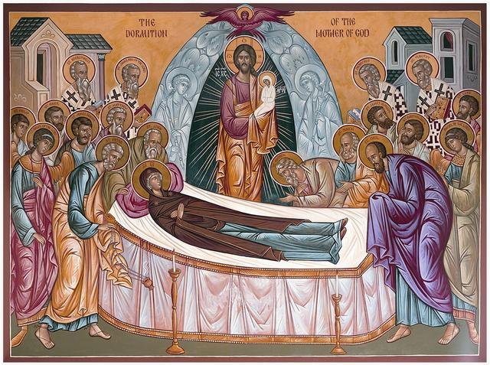

Where O death is your victory? Where O death is your sting?
The sting of death is sin and the power of sin is the law.
But thanks be to God who gives us the victory through Our Lord Jesus Christ!
1 Corinthians 15: 56-58

Gaze and read:
Sacred tradition assures us of the glorious death and assumption of Mary, body and soul, into heaven. She experienced the divine life straight after her death because of her important role in God’s plan for the world’s salvation. At the time of her death, the Apostles, scattered throughout the world, gathered at her bedside. Mary, eyes closed and hands crossed, still wears the blue of divinity while wrapping humanity in her red cloak. Christ, within the mandorla of divine glory, dominates the upper part of the icon. He is holding the soul of Mary, presented as if she were a newborn child, in his arms. We look to Mary’s bodily death with hope. This hope is in eternal life, and the resurrection of our bodies in a new creation.

Reflect:
- Mary is the model of what God will do for those who wait in faith, hope and love. In what ways does this icon inspire us to wait in joyful hope for the coming of our saviour Jesus Christ?
- Stand with the Apostles in this icon, sharing the final moments of Mary’s earthly life – a mixture of sadness and hope. Think of your own death-bed and death-bed scenes you have attended. What can we learn about putting our lives into perspective?
- We are a ‘pilgrim people’ always on the way. Mary accompanied the infant church in all its difficulties. She can be our companion now in all the difficulties of our lives.

Respond:
Lord, through the intercession of Mary your Mother and ours, give us unshakeable hope in the life of the world to come. Holy Mary, Mother of God, pray for us sinners now and at the hour of our death. Pray to Christ who gives us the hope that our mortal bodies will become like his in glory.

Rest:
Place yourself trustfully in the presence of Mary and let her cover you with her mantle.

Return:
What can you do to express devotion to Mary as you seek to be a better member of the church?

5th Glorious Mystery:
Our Lady is crowned Queen of Heaven

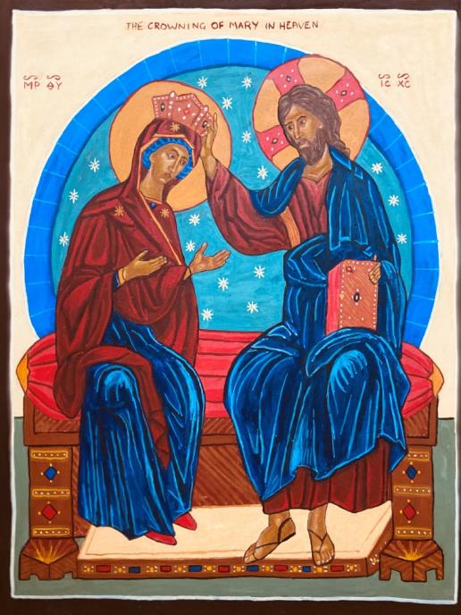

A great portent appeared in heaven:
a woman clothed with the sun, the moon under her feet
and on her head a crown of twelve stars.
Revelation 11:19

From this day, every generation shall call me blessed
for the Almighty has done great things for me.
Luke 1:50
Gaze and read:
The icon shows Jesus Christ in the divine sphere of heaven, welcoming and blessing his holy Mother – she who was faithful to the end, not only his earthly Mother but Mother of his infant Church. She is shown within the mandorla (the glory of God), a human creature, glorified and experiencing the presence of God. Her holy body was not left to undergo corruption but was exalted by its glorious ascent into heaven. The celebration of Mary’s assumption into heaven and crowning as Queen is a celebration of our human nature, for in Mary, human nature has reached its goal.

Reflect:
- -Mary lives as the model of what God desires for all of us. She is the great hope of our lives; she confirms our belief in the resurrection of the body and life everlasting. How do I make Mary an essential part of my faith?
- Mary’s reign as Mother of Christ and Queen of Heaven, assures us that God hears her prayers and will not refuse her. How does this give us more confidence in our devotion to Mary?
- Let the image of Mary being rewarded by her Son, instil in us a deep desire to share in the divine life. Let this icon illumine your life with God’s grace and help us to realise our true home is in heaven.

Respond:
Mary, you are my hope and my joy. All the desires of humanity were fulfilled in you. You are compassionate towards all, especially the poorest and those in most need. Now that nothing can limit your love, we pray that you remember us always and welcome us one day to our heavenly home.

Rest:
Gaze into the face of Mary and let her maternal love lead you to her Son and to the fullness of life he offers you. Trust in her protection and motherly embrace.

Return:
Let this meeting of Jesus and Mary in this icon prayer, refresh and renew your faith and hope in God’s promises. He wishes us to be with him forever. We are on our way – today!

The icons in this booklet were ‘written’ by
Sr Annette Kent
Susan Atkinson Hartlepool
Maureen Doyle Durham
Catherine Ferguson Murton
Maureen Ferguson Houghton
Rita Griskonyte Houghton
Sr Michael Sunderland
Lilian Simpson Jarrow
Zofia Skolimowska Hartlepool

