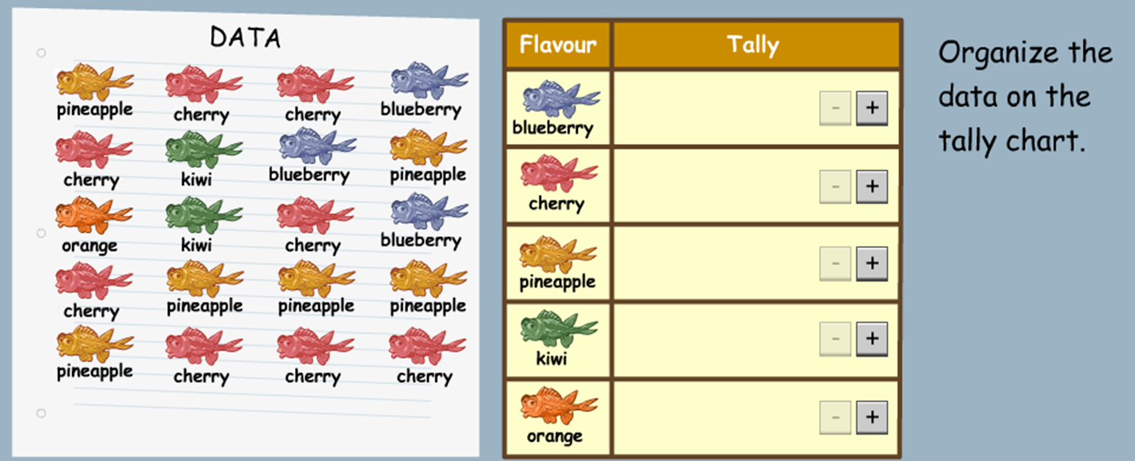
Jellyfish Sweet Data Handling
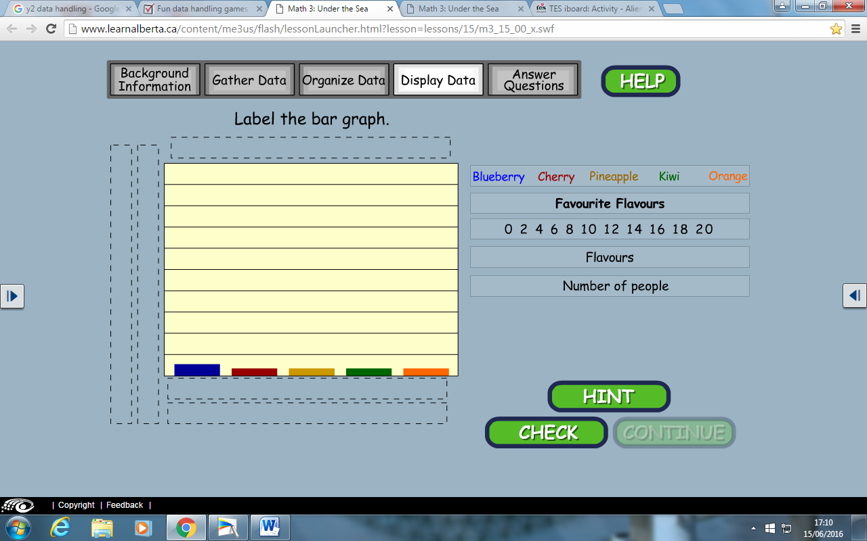
Copy the labels to place in the right position on the Chart.

