St Mark's R.C. Primary

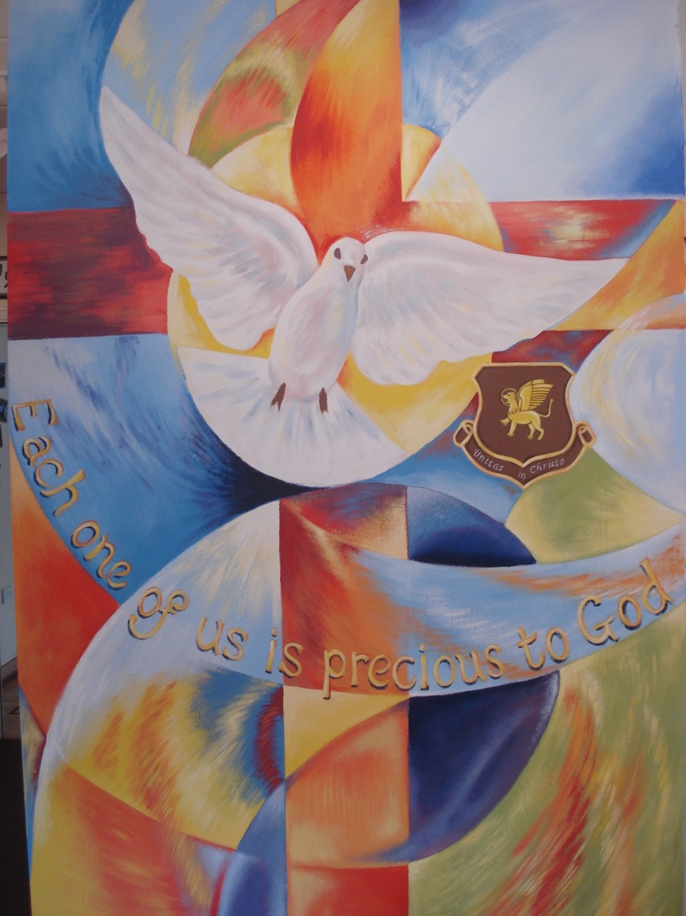

Welcome to Year 1

2019-2020

**Welcome to Year 1**

Thank you for taking the time to read this booklet. We aim to provide information that will help you to develop your child’s education.

Parents are a child’s first and enduring teachers.  You play a crucial role in helping your children learn.  Children achieve more when schools and parents work together in partnership.

Parents can help more effectively if they know what the school is trying to achieve and how they can help. We value your feedback, so please let us know what you find difficult and require support with. We would also like to know what you find to be useful to help us continue to develop the important relationship between school and home.

When you ask your Reception child what they’ve done at school today, the answer is often, ‘I played.’ But their school day in Year 1 can seem very different – and a bit of a culture shock. In Reception, children get used to a play-based, free-flowing experience. They might be guided by the staff, but a lot of the time, they get to choose what they play with, when and with whom. They gravitate towards the things they enjoy doing, and how they spend their time is largely in their own hands.

In contrast, the Year 1 learning experience tends to be more formal. The National Curriculum sets out clear learning goals across every subject, and there are targets including knowing certain number facts and being able to spell a list of words accurately. Children are expected to take a phonics screening check towards the end of Year 1.

There appears to be a lot more furniture and fewer toys, as children spend more time sitting at tables with a greater focus on pencil and paper tasks.

Kind regards,

Miss Kerr, Mrs Hardy and Mrs Crawford

Reading

Initially, the best way to help your child to begin learning to read is to read to them and talk to them about a wide variety of books and the things that you do and see in everyday life.  This helps them to develop a love of books and a varied vocabulary, which will help them to understand the words in books later on. The main key skills for children to develop can be found on the Reading Learning Wall within your child’s books which is also handed out on parents evening and on the school’s website the national curriculum expectations for year groups are available.

Once your child begins learning to read at pre-school and school, it is vitally important that you read at home with your child every day.  They should be reading the book given to them by school and reading should be continued at the weekend and during school holidays. The more they read and enjoy reading, usually the quicker they learn how to read and develop strategies to work out words that they do not know.

**If a comment is not made in their reading record book, then your child’s book will not be changed. Books are changed each Monday**.

Here are some ways to approach the ‘difficult job’ of learning how to read.  We hope you will find them useful

* Most important of all, make reading with you as enjoyable as possible - not always easy after a hard day at work and school, but do try to persevere!

 * Look at the book first, talking about what you can see happening in the pictures. Try to predict the story and possible unknown words.

* The pictures are a really important tool to help the children read. Please do not cover them up. If your child is becoming too reliant on the pictures, encourage them to point to the words to draw their attention back to the text.

 * Many words can be sounded out, e.g: c a t. However, words such as ‘was’ are a little trickier as sounding them out does not work. The children just need to learn how they look.

* Look out for words they already know within longer words e.g.: board

* Remind children to think about how speech might be said to encourage them to read with expression. Punctuation helps your child to read with intonation and brings a book to life.

* Question your child about events in the book to check that they have understood what they are reading

* Retelling the story so far or predicting what might happen next will help you to gauge their understanding of what they have read.

 * Encourage your child to read a variety of different types of story-books, information books, magazines, newspapers, letters etc.

Join your local library and make use of their fabulous resources. There are also age appropriate on-line books available on the Oxford Owl website, which you can subscribe to for free.

https://www.oxfordowl.co.uk/for-school/for-school/oxford-owl-ebook-collection

**Reading Stages**

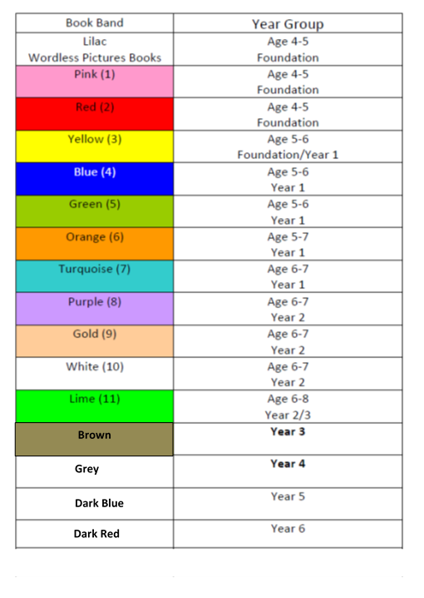

This chart can only give a rough idea of the right level for your child. There will be a wide range of reading abilities in any school year. As a rough guide, children should be able to read at least 90% of the words on the page without any problem. They should also demonstrate good understanding of the text they read through comprehension questions. If the book is too easy, they can become bored. If it’s too difficult, they can become frustrated, and may have to concentrate so hard on reading the words that they lose the enjoyment of understanding the story.

Bug Club <https://www.activelearnprimary.co.uk/login?c=0>

**Writing**

Please refer to the Year 1 Writing Wall to see what the expectations are for the end of Year 1.

During Year 1, children are taught to write sentences by:

* saying out loud what they are going to write about
* re-reading what they have written to check that it makes sense
* discussing what they have written with the teacher or other pupils
* leaving spaces between words
* joining short sentences using and punctuating sentences using a capital letter and a full stop, question mark or exclamation mark The best way to get better at writing is to practise it by writing in meaningful situations with real purpose.
* Encourage your child to write:
* birthday cards shopping lists
* letters to relatives and friends
* reminders for things for school
* instructions for games they have made up or models they have made out of Lego etc.
* book or film reviews
* scrap books
* e-mails
* a diary when they do interesting things

 Ensure handwriting is correctly formed and legible.  Encourage correct pencil   grip to help them write with ease.

 Encourage children to sound out simple words, look for patterns in more complicated sets of words and eventually learn and apply spelling rules that they have encountered.

Spelling (this begins after Christmas)

The children learn to spell during daily Letters and Sounds lessons. From time to time, we will send words home that the children will need to learn to spell. Help your child to learn their spellings by the

                                        ‘**Look, Cover, Say, Write, Check’**

**Method**, where your child looks at each word in turn, covers it up, says it to themselves, writes it down and then checks to see if it is correct.  If it is incorrect they try again.  This should be done often to ensure that they really do learn the look and arrangement of the word as well as how it sounds.   Do not expect your child to learn their spellings by testing them every night.   Test them once, before they are to be tested in school if you like, but testing does not help them to learn them, it only assesses whether or not they do know them.

**Spoken Language** (Word-aware in phonic sessions)

Young children love to talk and share their ideas. At times they need help listening to others and valuing their opinions. In Year 1, children are taught to: listen, ask relevant questions, build their vocabulary, give descriptions and explanations, participate in conversations, explore ideas and to speak audibly and fluently.

**Drama and role-play** can contribute to the quality of children’s writing by providing opportunities for pupils to develop and order their ideas through playing roles and improvising scenes.

Letters and Sounds

**Synthetic phonics** — refers to an approach to the teaching of reading in which phonemes [sounds] associated with particular graphemes [letters] are pronounced in isolation and blended together. For example, children are taught to take a single-syllable word such as cat apart into its three letters, pronounce a phoneme for each letter in turn c-a-t, and blend the phonemes together to form a word. Synthetic phonics for writing reverses the sequence: children are taught to say the word they wish to write, stretch it into its phonemes and say them in turn, for example d-o-g, and write a grapheme for each phoneme in turn to produce the written word, dog.

**Glossary of terms**

The following terms and their definitions have been taken from the National Curriculum.

**blend**— to draw individual sounds together to pronounce a word, e.g. s-n-a-p, blended together, reads snap

**split digraph** — two letters, split, making one sound, e.g. a-e as in make or i-e in site. We explain this as two letters holding hands to make one sound. We may also refer to ‘magic’ e if that helps the children remember the rule. The walking, talking phrase for vowel diagraphs still works.

**grapheme** — a letter or a group of letters representing one sound, e.g. s, sh, ch, ie,  igh, ough, (as in 'though')

**grapheme-phoneme correspondence (GPC)** — the relationship between sounds and the letters which represent those sounds; also known as 'letter-sound correspondences'

**phoneme —** the smallest single identifiable sound, e.g. the letters 'sh' represent just one sound, but 'sp' represents two (s and p)

**segmen**t — to split up a word into its individual phonemes in order to spell it, e.g. the word 'cat' has three phonemes: c-a-t

**VC, CVC, CCVC** — the abbreviations for vowel-consonant, consonant-vowel-consonant, consonant-consonant-vowel-consonant, and are used to describe the order of letters in words, e.g. am, Sam, slam.

**mnemonic** — a device for memorising and recalling something, such as a snake shaped like the letter 'S'. We also teach actions from the Jolly Phonics scheme eg ai as in r-ai-n.

Games to support learning available on the internet www.letters-and-sounds.com/ .

www.phonicsplay.co.uk/InteractiveResources.htm

s Weave hand in an s shape, like a snake, and say ssssss

a   Wiggle fingers above elbow as if ants crawling on you and say a, a, a.

t Turn head from side to side as if watching tennis and say t, t, t.

i Pretend to be a mouse by wriggling fingers at end of nose and squeak i, i, i.

p   Pretend to puff out candles and say p, p, p.

n Make a noise, as if you are a plane - hold arms out and say nnnnnn.

c k Raise hands and snap fingers as if playing castanets and say ck, ck, ck.

e Pretend to tap an egg on the side of a pan and crack it into the pan, saying eh, eh, eh.

h Hold hand in front of mouth panting as if you are out of breath and say h, h, h.

r   Pretend to be a puppy holding a piece of rag, shaking head from side to side, and say rrrrrr.

m   Rub tummy as if seeing tasty food and say mmmmmm.

 d Beat hands up and down as if playing a drum and say d, d, d.

g Spiral hand down, as if water going down the drain, and say g, g, g.

o Pretend to turn light switch on and off and say o, o; o, o u Pretend to be putting up an umbrella and say u, u, u.

 l Pretend to lick a lollipop and say l l l l l l.

 f Let hands gently come together as if toy fish deflating, and say f f f f f f.

b Pretend to hit a ball with a bat and say b, b, b.

ai Cup hand over ear and say ai, ai, ai.

j Pretend to wobble on a plate and say j, j, j.

oa Bring hand over mouth as if you have done something wrong and say oh!

ie Stand to attention and salute, saying ie ie. ee   or Put hands on head as if ears on a donkey and say eeyore, eeyore.

z Put arms out at sides and pretend to be a bee, saying zzzzzz.

w Blow on to open hand, as if you are the wind, and say wh, wh, wh.

ng Imagine you are a weightlifter, and pretend to lift a heavy weight above your head, saying ng...

v Pretend to be holding the steering wheel of a van and say vvvvvv.

oo oo Move head back and forth as if it is the cuckoo in a cuckoo clock, saying u, oo; u, oo. (Little and long oo.)

y Pretend to be eating a yogurt and say y, y, y.

x Pretend to take an x-ray of someone with an x-ray gun and say ks, ks, ks.

ch Move arms at sides as if you are a train and say ch, ch, ch.

sh   Place index finger over lips and say shshsh.

th th Pretend to be naughty clowns and stick out tongue a little for the th, and further for the th sound (this and thumb).

qu Make a duck's beak with your hands and say qu, qu, qu.

ou Pretend your finger is a needle and prick thumb saying ou, ou, ou.

oi Cup hands around mouth and shout to another boat saying oi! ship ahoy!

ue Point to people around you and say you, you, you.

er Roll hands over each other like a mixer and say ererer.

ar   Open mouth wide and say ah. (UK English) Flap hands as if a seal, and say ar, ar, ar. (US English)

**Mathematics**

At St Mark’s RC Primary School we are dedicated to promoting enthusiasm and enjoyment of mathematics through the provision of a range of experiences which enable all children to achieve and which develop, maintain and stimulate their curiosity and interest. We place great emphasis on encouraging children to talk about their ideas in mathematics and to reason mathematically, using a wide range of vocabulary. Developing the children’s confidence and accuracy with their understanding and recall of mathematical facts and knowledge and the application of these skills and concepts to real-life problem solving contexts is also at the heart of our teaching and learning.

**A typical mathematics lesson**

The daily mathematics lesson lasts approximately sixty minutes. There is a great emphasis on children talking about mathematics and on using mathematical vocabulary. Mathematics resources such as counters are used to provide children with a range of images to help develop their mathematical understanding. Although children learn to record their mathematical learning, some lessons are practical and often take place outside.

It is important to relate learning within mathematics to the real world, including the outside environment, and learning in other subject areas. Therefore, topic work will be included where it usefully supports mathematical investigations or learning in a cross-curricular setting.

**Expectations in Mathematics**

There are clear national expectations about what every child should be achieving in mathematics.

**How you can help your child’s maths learning**

One of the most valuable things you can do is talk to your child about their maths learning. **Ask them what they have been learning and encourage them to explain.** We all use maths in our everyday lives which means that are plenty of opportunities to help your child with their maths learning by involving them in everyday activities.

1. Play a board game with your family.

2. Talk about any maths learning that they bring home from school. This will usually follow on from activities in class.

3. Ask them to help you when you are doing things with money, or measuring or weighing.

4. Tell the time.

 5. Help them to manage their money by looking at the price of things and working out if they can afford them.

 6. Help your child to learn their number bonds to 10, then 20

7. Use an educational game on the computer:

**TIMES TABLES**

**By the end of year 4, all children should know their multiplication facts and related division facts up to 12 x 12 and be able to demonstrate quick recall of these facts.**

Children who are secure with their quick recall of times tables facts make faster progress, as they are able to apply this knowledge to all areas of maths, including mental calculations and problem solving in real-life contexts.

Children should therefore be practicing their tables regularly - 5 minutes a day is much more beneficial than 30 minutes once a week. Each week, your child will be tested on their knowledge of the table they are working on. Cards will be sent home to support this but online games are great too!

**Years 1 to 4**

In order to best support the children to learn their times tables, and to become secure with their quick recall and application of times tables facts, each term your child will focus on a particular times table. They will be taught strategies for learning these times tables in school and practise every day in class. For Home Learning, the children will also focus on the specific times tables that they are working on.

At the beginning of each new academic year, the children will revise the times tables learnt during the previous year, before then moving onto a new times table.



The chart below shows the focus areas for each term for each year group:

**Religious Education**

Religious Education is central to the educative mission of the Church.

*‘At the heart of Catholic education lies the Christian vision of the human person. This vision is expressed and explored in Religious Education.’*

Religious Education is ‘the core of the core curriculum.’

*‘Therefore Religious Education is never simply one subject among many, but the foundation of the entire educational process. The beliefs and values studied in Catholic religious education inspire and draw together every aspect of the life of a Catholic school….. All pupils have the right to receive an overall education which will enable them, in the light of the faith of the Church, to engage with the deepest questions of life and find reasons for the hope which is within them. Religious Education is, then, the core subject in a Catholic school.’1*

Religious Education is the systematic study of the teaching of the Church and the mystery of Christ and is a rigorous academic subject in its own right.

*Religious Education is regarded as an academic discipline with the same systematic demands and the same rigour as other disciplines.* 2 As such it is to be taught, developed and resourced with the same commitment as any other subject.

*“Excellence in religious education, then, will be characterised by a clarity of succinct religious learning objectives and of key content, by appropriate methodologies, rigour, richness of resources, achievement of identified outcomes and accurate methods of assessment. Classroom RE will be a challenging educational engagement between the pupil, the teacher and the authentic subject material.”* 3

Whilst evangelisation and catechesis are happening in our school for some pupils, the specific contribution Religious Education makes to the Catholic Life of the school is primarily educational and will be planned, taught, assessed and monitored with the same rigour as other curriculum subjects.

The outcome of Classroom Religious Education is:

*“religiously literate and engaged young people who have the knowledge, understanding and skills – appropriate to their age and capacity – to reflect spiritually, and think ethically and theologically, and who are aware of the demands of religious commitment in everyday life”*.4

**Religious Education - Curriculum Time Allocation**

10% of curriculum time is allocated to Religious Education. This does not include Collective Worship.

**The Aims of Religious Education at St Mark’s are:**

* To present engagingly a comprehensive content which is the basis of knowledge and understanding of the Catholic faith;
* To enable pupils continually to deepen their religious and theological understanding and be able to communicate this effectively;
* To present an authentic vision of the Church’s moral and social teaching so that pupils can make a critique of the underlying trends in contemporary culture and society;
* To raise pupils’ awareness of the faith and traditions of other religious communities in order to respect and understand them;
* To develop the critical faculties of pupils so that they can relate their Catholic faith to daily life;
* To stimulate pupils’ imagination and provoke a desire for personal meaning as revealed in the truth of the Catholic faith;
* To enable pupils to relate the knowledge gained through Religious Education to their understanding of other subjects in the curriculum;
* To bring clarity to the relationship between faith and life, and between faith and culture.5

**Programme of Study**

To fulfil the above aims and to address the four areas of study outlined in the Religious Education Curriculum Directory, 2012 – Revelation, Church, Celebration and Life in Christ - the **‘Come and See’** programme is used as recommended by the Diocese.

**Other Religions**

Two other religions are taught from EYFS to Year 6 following the programme of study in ‘Come and See’. These are Judaism, which is usually taught in the autumn, and Islam*,* which is taught either in the spring or summer. At least one week’s teaching and learning time per year is given to each.

**Come and See Overview of the Year 2019-2020**

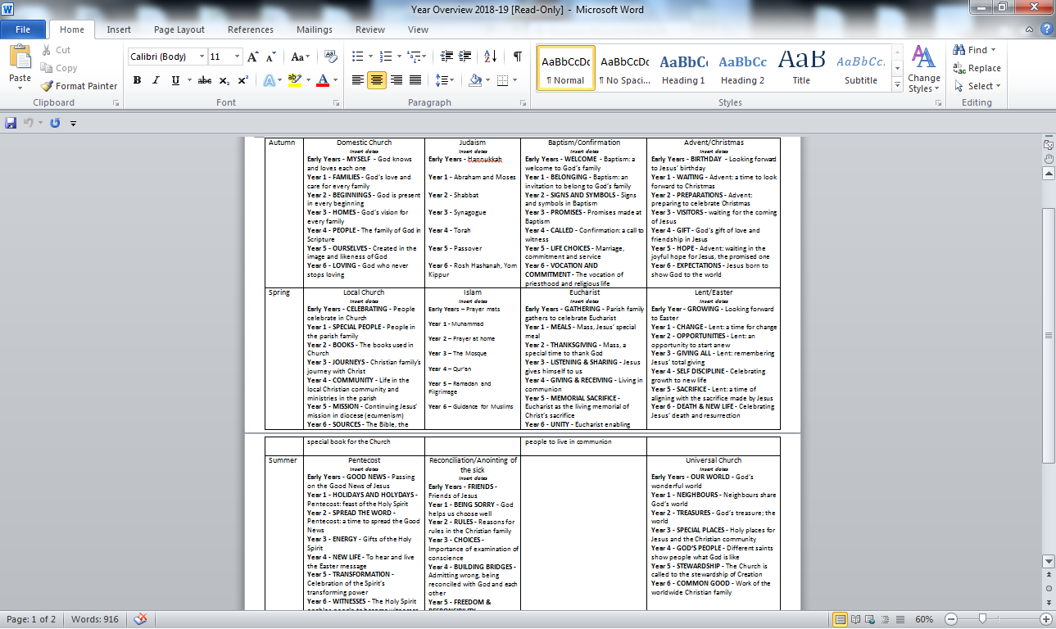

**Collective Worship**

**The Nature of Collective Worship**

Collective worship in a Catholic school names and celebrates God’s presence in our lives. It is concerned with giving glory, honour, praise and thanks to God. It is our loving response, in word and action, to God’s invitation to enter into relationship, made possible through the work of Jesus Christ and the witness of the Holy Spirit.

‘The celebration of Catholic liturgies and prayers as an integral part of the learning and teaching should enable the school community to become reflective, experience the presence of God and should develop a mature spiritual life.’[1]

**Legal Requirements**

It is a legal requirement that there is a daily act of worship offered for all pupils. This can take place at any time during the school day and can be either a single act of worship for all pupils, or separate acts of worship in school groups. Holding an assembly that includes a prayer, said either by the teacher or everyone present, does not fulfil this requirement. Collective worship and assembly are distinct

activities. They may sometimes form part of the same gathering, but the difference between the two will always be made clear.

**The Place of Collective Worship in the Life of St Mark’s RC Primary School**

Worship is an integral part of school life and central to the Catholic tradition.

Collective worship takes into account the religious and educational needs of all who share in it:

* Those who form part of the worshipping community in church;
* Those for whom school may be their first and only experience of church;
* Those from other Christian traditions – or none;
* Those from other faith backgrounds.

**The Aims of Collective Worship**

Collective Worship in St Mark’s aims to provide opportunities for all pupils and staff:

* To contemplate the mystery of God
* To reflect on spiritual and moral issues
* To explore personal beliefs
* To respond to and to celebrate life
* To experience a sense of belonging and to develop community spirit
* To develop a common ethos and shared values
* To enrich religious experience
* To grow in liturgical understanding and development
* To pray using prayers which are part of the Catholic tradition
* To reinforce positive attitudes
* To participate fully
* To take time out ‘to wonder at’, ‘to come to terms with’ and ‘to give worth to.’

**Science in Year 1**

Science enables children to discover the world around them. It stimulates curiosity and leads to the development of investigative skills so they can discover how the world around them works. It also enables children to make meaningful links to both the natural and man-made environment they live in.

Science is essentially a practical subject and the children are given opportunities for careful observation and investigation. Children participate in a wide variety of problem solving activities. They are encouraged to devise their own experiments and communicate their findings in a variety of ways.

Throughout year 1, the science curriculum will be embedded within our Learning Journeys.  Over the year, children will cover the following areas:

Plants

Animals including humans

Uses of everyday materials

Seasonal changes

The children get a chance to explore science within the environmental area, pond area and garden. Opportunities to investigate habitats on the beach will also become a feature of sessions. Please ensure your child comes to school equipped with old clothes and wellies for these sessions. You will be advised of the dates in the termly letter.

At home Children are naturally inquisitive and interested in the world that surrounds them.  Whenever you are together, they are trying to make sense of things that they encounter and develop their understanding.

**You could:**

* Encourage them to ask questions such as ‘How?’ ‘Why?’ and ‘What will happen if…?’ and decide how they might find answers to them.  Talk is really important – don’t undervalue your answers to the value of “Why?” You could use non-fiction books you might have at home, visit the library or use the Internet to help them discover ways of finding the answers they seek.

 * Encourage them to predict what might happen.

* Help them to recognise when a test or comparison is unfair.

* Provide opportunities for them to explore, using the senses of sight, hearing, smell, touch and taste as appropriate.

* Encourage them to communicate what happened through speech, writing, drawing, or ICT.

* Help them to make simple comparisons e.g. hand spans or shoe sizes in your family and identify simple patterns.

* Compare what happened with what they expected and try to explain it, drawing on their knowledge and understanding.

Make the most of situations that naturally develop when you are together.  Each season brings its own learning opportunities. Enjoy them and celebrate them! Children are on the whole eager to learn.  Also be aware of when they have “had enough” and it is time to stop!

**How to help**

You can help your child by pointing out science in everyday life and by beginning to use more specific vocabulary.

**Useful websites:**

http://www.bbc.co.uk/bitesize/ks2/science/

http://www.woodlands-junior.kent.sch.uk/revision/Science/

http://www.primaryscience.ie/activities_science_home.php

**Non-Core subjects**

Throughout their time in Year 1, the children will complete history, geography, art design and technology, computing, music, Religious Education, PSHE, PE and Languages lessons. The national curriculum requirements and coverage for these subjects are shown on the Year 1 Curriculum map, which is found on the school’s website.

**Keeping Children Safe**

Children walking home from school

Children from foundation upwards should be collected by an adult from the class door. If another adult is collecting your child, please let the class teacher know – even if you have arranged for another parent to collect.

Children in year 3 and 4 will not be allowed to walk home on their own.

Children in year 5/6 frequently walk home on their own; please do let the class teacher know of your wishes.

All children must be collected from after school clubs.

Internet Safety Within school we have strict filters on our computers that help block inappropriate sites for the children. The children are frequently reminded of Internet Safety Rules.

We urge parents to keep a close eye on the internet usage that children access at home.  Children will not use Social Media sites in school, as primary school children are too young to be accessing them.

Information for Parents can be found:  CEOP: www.ceop.gov.uk  Think U Know: www.thinkuknow.co.uk Child net   www.childnet-int.org

Our website offers more information or links.

Safeguarding: Our Senior Designated Person is **Mrs Miler**

Our Deputy Designated Person is **Mrs Henderson.**

 If you have any concerns about the welfare of any of the children within the school, please do speak with us.

When concerns are raised or noticed, we have to make sure that any information is recorded. Parents will be contacted to discuss any concerns as soon as possible. On a few occasions, where there may be serious concerns, the information has to be shared with our partners in the Police, Social Services and in Health first. Let your child’s class teacher know if something has happened that means your child is upset or unhappy; or if there is something you feel we ought to know. This will enable us to support your child.

If you suspect ANY child is being neglected, abused or facing harm, let the school know.

Telephone: 0191 2869349

1.